Development of a Multi-Actor Tuition Management Platform

Fatema Tuz Zohura
ID: 22203201

A Practicum in the Partial Fulfillment of the Requirements for the Award of Bachelor of Computer Science and Engineering (BCSE)



Department of Computer Science and Engineering
College of Engineering and Technology
IUBAT—International University of Business Agriculture and Technology

Spring 2026
Development of a Multi-Actor Tuition Management Platform

Fatema Tuz Zohura

A Practicum in the Partial Fulfillment of the Requirements for the Award of Bachelor of Computer Science and Engineering (BCSE)
The practicum has been examined and approved,

Prof. Dr. Utpal Kanti Das
Chairman

Shahinur Alam
Co-supervisor, Coordinator, and Assistant Professor

Snaholata Mondal
Supervisor and Lecturer

Department of Computer Science and Engineering
College of Engineering and Technology
IUBAT—International University of Business Agriculture and Technology

Spring 2026

Letter of Transmittal

12 May, 2026
The Chair
Practicum Defense Committee
Department of Computer Science and Engineering
IUBAT–International University of Business Agriculture and Technology
4 Embankment Drive Road, Sector 10, Uttara Model Town Dhaka 1230, Bangladesh.

Subject: Letter of Transmittal.

Dear Sir,
It is my pleasure to submit here with my dissertation, which has been prepared under the sound and dynamic leadership of a personality like you.
This report is about the “Development of an Artificial Intelligence-Driven Agricultural Assistance Platform”. I have tried my level best to collect the relative information as possible in preparing the report. During the preparation of the report, I have experienced a lot that will help me a great deal in my career. It has enlightened my practical knowledge regarding dividends and their impact on the stock price. I will be able to explain anything for more clarification if necessary.

I would like to thank you for giving me the opportunity to do a report on the above-mentioned topic.

Yours sincerely

_____________
Fatema Tuz Zohura
22203201

Internship Certificate

Student’s Declaration

This is to certify that the work presented in this report titled, “Development of an Artificial Intelligence-Driven Agricultural Assistance Platform”, is the outcome of the investigation and research carried out by the following student under the Department of Computer Science and Engineering, International University of Business Agriculture and Technology.

Yours sincerely,
______________
Fatema Tuz Zohura
22203201

Supervisor’s Certification

The Practicum report on “Development of an Artificial Intelligence-Driven Agricultural Assistance Platform” has been submitted by Name: Fatema Tuz Zohura bearing ID:22203201, as satisfactory in partial fulfillment of the requirement for the degree of Bachelor of Science in Computer Science and Engineering in May 2026.
He is now allowed to submit the report. I wish him the best of luck in his future undertakings.

Practicum Supervisor
________________
Snaholata Mondal
Supervisor and Lecturer
Department of Computer Science and Engineering
IUBAT – International University of Business Agriculture and Technology

Abstract

With the current educational environment, matching qualified teachers to students' needs requires a simplified, clear, and safe platform. In this paper, we discuss the development of the Design and Implementation of a “Multi-Actor Tuition Management Platform”, an integrated Tutor Management System that intervenes between academic professionals and guardians. The system is divided into three main actors, and each has a dedicated dashboard to help them manage their work: Admin, Tutor, and Guardian/Student.
The platform also has a powerful Tuition Posting and Approval feature, where guardians can post their education needs, which are then reviewed and approved by the Admin to guarantee the quality and authenticity of the education. Tutors may search for active listings, apply for jobs, and submit a CV (curriculum vitae) to the professional for review. The system is equipped with a dedicated Real-time Chat Module that enables communication between the guardians and tutors and the administration team for verification and support.
Design and Implementation of a Multi-Actor Tuition Management Platform streamlines tutor searches by verifying tutors, tracking applications, and providing secure communication, reducing the inefficiency of traditional tutor search platforms. This is an agile and user-driven solution that boosts the reliability of the private education sector recruitment process with formalized digital management.

Acknowledgement

I would like to take this opportunity to express my sincere gratitude to all those who supported and encouraged me throughout the completion of my practicum program and the preparation of this report on the “Development of the Multi-Actor Tuition Management Platform”. Their guidance, patience, and encouragement played a significant role in enabling me to successfully complete this work.

I am thankful to the institution for providing a supportive academic environment that fosters both intellectual development and personal growth. I would also like to pay special tribute to the late Abdur Rab, whose visionary leadership opened new pathways for higher education in the non-government sector of Bangladesh. I am equally grateful to Abdur Rab for his continued leadership and guidance, which have greatly benefited the institution and its students.

My sincere appreciation goes to Prof. Dr. Utpal Kanti Das, Professor and Chair, for his valuable advice, motivation, and encouragement throughout the practicum period. Above all, I am deeply indebted to my supervisor, Snaholata Mondal, Lecturer, for his constant guidance, constructive feedback, and continuous encouragement, which were instrumental in shaping this work into its final form.

Completing this practicum has significantly enhanced my understanding of the subject matter, strengthened my technical skills, and provided valuable experience in research and report writing. I am truly grateful for the opportunity to work on this project, which has been both academically enriching and professionally rewarding.

Table of Contents

Letter of Transmittal iii
Internship Certificate iv
Student’s Declaration v
Supervisor’s Certification vi
Abstract vii
Acknowledgement viii
List of Figures xiii
List of Tables xv
Chapter 1: Introduction 1
1.1 Background & Study: 2
1.2 Methodology: 3
1.3 Objectives: 5
1.4 Process Model: 5
1.5 Feasibility Study: 7
1.5.1 Technical Feasibility: 7
1.5.2 Economic Feasibility: 7
1.5.3 Feasibility of operations: 8
Chapter 2: Organizational Overview 9
2.1 Organizational Overview: 10
2.2 Organization Services: 10
2.2.1 Core Values 10
2.3 Organization Service: 10
2.4 Organization Vision 11
2.5 Organization Mission 11
2.6 My Position in the Organization: 11
2.7 Address of the Organization: 11
Chapter 3: Requirement Engineering 12
3.1 Requirement Categories 13
3.1.1 User Requirements 13
3.2 System Requirements 14
3.3 Functional Requirements 14
3.4 Non-Functional Requirements 15
3.5 Use Case Diagram 15
Chapter 4: Analysis 17
4.1 Software Analysis Pattern 18
4.2 Activity Diagram 20
4.2.1 Activity Diagram for Guardian\Student (User) Registration 20
4.2.2 Activity Diagram for Tutor Registration 21
4.2.3 Activity Diagram for Tutor Login 21
4.2.4 Activity Diagram for Guardian/Student Login 22
4.2.5 Activity Diagram for Admin Login 23
4.2.6 Guardian/Student Overall Activity Diagram 24
4.2.7 Admin Overall Activity Diagram 25
4.2.8 Tutor Overall Activity Diagram 26
4.3 Swimlane Diagram: 27
4.3.1 Swimlane Diagram for Admin 27
4.3.2 Swimlane Diagram for Tutor 28
4.3.3 Swimlane Diagram for Guardian\Student 29
4.4 Class Diagram 30
4.5 Sequence Diagram 31
Chapter 5: Project Management 32
5.1 Risk Analysis 34
5.2 Risk Planning 35
5.3 The RMMM Plan (Risk Mitigation, Monitoring, and Management) 36
5.3.1 Risk Mitigation 36
5.3.2 Risk Monitoring 36
5.3.3 Risk Management 36
Chapter 6: Project Planning and Scheduling 38
6.1 System Project Estimation 39
6.2 Functional-Oriented Metrics 40
6.3 Identifying Complexity 41
6.3.1 Transaction Functions 41
6.3.2 Data Functions 42
6.4 Unadjusted Function Point Contribution 42
6.5 Performance and Environmental Impact 43
6.6 Adjusted Function Point Contribution 43
6.7 Project Schedule Chart 43
6.8 Project Cost Estimation 44
Chapter 7: Interface Design 46
7.1 Interface Design 47
7.1.1 Homepage: 47
7.1.2 Tution postings on the homepage: 48
7.1.3 Login page 48
7.1.4 Registration page 49
7.1.5 Guardian Dashboard 49
7.1.6 Admin Dashboard 50
7.1.7 Admin Dashboard-2 51
7.1.8 Approved Tuition posts 51
7.1.9 Pending posts 52
7.1.10 Tutor Dashboard 52
7.1.11 Tutor profile (with verification status) 53
7.2 Database 53
7.3 Data Flow Diagram 53
7.3.1 Context level (Level 0) 54
7.3.2 Level 1 55
7.3.3 Level 2 Process 1 56
7.3.4 Level 2 Process 2 56
7.3.5 Level 2 Process 3 57
7.3.6 Level 2 Process 4 57
7.3.7 Level 2 Process 5 58
7.3.8 Level 2 Process 6 58
7.4 ERD Diagram 59
Chapter 8: System Quality and Testing 60
8.1 Software Quality Management Process 61
8.2 Software Test Cases 61
Chapter 9: Ethical Consideration 66
9.1 Ethical Considerations in the Software Development Process 67
9.1.1 Data Privacy and Security 67
9.1.2 Intellectual Property 67
9.1.3 User Impact 68
9.1.4 Bias and Fairness 68
9.1.5 Responsibility to Stakeholders 68
9.1.6 Professional Responsibility 69
9.2 Sustainability in the Software Development Process 69
9.2.1 Economic Sustainability 69
9.2.2 Social Sustainability 69
Chapter 10: Conclusion 71
10.1 Brief Overview of the Project 72
10.2 Proposed System Benefits 72
10.3 Limitations of the Project 73
10.4 Practicum and Its Value 73
10.5 Future Plans 74
References 75

List of Figures

Figure 1.1 Incremental Process Model 7
Figure 2.1 Organizational Structure of Estrella Global Solution 15
Figure 3.1 Use Case Diagram of AI Powered Assistance Platform 22
Figure 4.1 Software Analysis Pattern Layer 25
Figure 4.2 User Registration Activity Diagram 27
Figure 4.3 Activity Diagram for User Login 28
Figure 4.4 Activity Diagram for Admin Login 29
Figure 4.5 Multimodal Query Processing Activity Diagram 30
Figure 4.6 Automated Disease Diagnosis Activity Diagram 31
Figure 4.7 Community Engagement and Moderation Activity Diagram 32
Figure 4.9 Overall Activity Diagram for Users 34
Figure 4.10 Overall Activity Diagram for Admin 35
Figure 4.11 Crop Disease Diagnosis Workflow Swimlane Diagram 36
Figure 4.12 Multilingual Voice Interaction Swimlane Diagram 37
Figure 4.13 Community Forum Moderation Swimlane Diagram 38
Figure 4.14 Administrative Reporting and System Maintenance Swimlane Diagram 39
Figure 4.15 User Login Swimlane Diagram 40
Figure 4.16 Admin Login Swimlane Diagram 41
Figure 4.17 Class Diagram of AI Powered Agriculture Assistance Platform 42
Figure 4.18 Sequence Diagram of AI Powered Agriculture Assistance Platform 43
Figure 21.1 Risk Management Cycle 45
Figure 6.1 Gantt Chart Project Schedule Diagram 60
Figure 7.1 DFD Level 0 Diagram 65
Figure 7.2 DFD Level 1 Diagram 66
Figure 7.3 DFD Level 3 Diagram 67
Figure 7.4 Homepage UI Screen 67
Figure 7.5 Disease Detection Report for Admin 68
Figure 7.6 Admin Dashboard 68
Figure 7.7 AI Model Manager UI 69
Figure 7.8 Disease Detection Page 69
Figure 7.9 Authentication Group UI 70
Figure 7.10 Chatbot UI 70
Figure 7.11 Crops Manager UI 71
Figure 7.12 Detection Income Log UI 71
Figure 7.13 Crop List Disease Detection 72
Figure 7.14 Forum Feed UI 72
Figure 7.15 Payment Gateway 73
Figure 7.16 Login Page UI 73
Figure 7.17 Forum Post Management UI 74
Figure 7.18 Revenue Report UI 74
Figure 7.20 Payment UI 75
Figure 7.21 Payment Success Message UI 75
Figure 7.22 Profile Settings UI 76
Figure 7.23 Registration Page UI 76
Figure 7.24 Detection Report UI 77
Figure 7.25 Transaction Log for Admin Page UI 77
Figure 7.27 View Chat Session UI 78
Figure 7.28 User Management UI 78
Figure 7.29 Users List UI 79
Figure 7.30 User Dashboard UI 79
Figure 7.31 Users Chat Log for Admin 80
Figure 7.32 Database Schema 80
Figure 7.32 Entity Relationship Diagram for AI Powered Agriculture Assistance Platform 86
Figure 9.1 Sustainability in Software Development 94

List of Tables

Table 5.1 Risk Identification Table 46
Table 5.2 Risk Analysis Table 47
Table 5.3: Risk Planning Table 48
Table 5.4: Risk Mitigation, Monitoring, and Management Table 50
Table 6.1: Function Points (Farmer) 55
Table 6.2: Function Points (Admin/Expert) 55
Table 6.3: Unadjusted Function Point Contribution (Transaction Functions) 56
Table 6.4: Unadjusted Function Point Contribution (Data Functions) 57
Table 6.5: Performance and Environmental Impact (GSC) 58
Table 6.6 Estimated Cost (Industry Scenario) 59
Table 6.7: Personnel Cost 61
Table 6.8: Expected Hardware Cost 61
Table 6.9: Expected Software Cost 62
Table 6.10: Expected Other Cost 62
Table 6.11: Total Estimated Cost Summary 63
Table 7.1: Farmer Table 83
Table 7.2: Chatbot Query Table 83
Table 7.3: Crop Image Table 84
Table 7.4: Disease Diagnosis Table 84
Table 7.5: Expert Table 84
Table 7.6: Community Post Table 85
Table 8.1: Test Cases for the Agricultural Assistance System 90

Chapter 1: Introduction

Private tuition is a significant part of the academic support system, especially in areas where one-to-one guidance is crucial to supplement the institution's education system. Until now, finding a tutor to match a student or guardian's requirements has been informal: people recommend a tutor or post an ad in a few places online. This de-structured approach can result in inefficiencies, a lack of transparency, and difficulty verifying tutor credibility. To overcome these challenges, the Multi-Actor Tuition Management Platform has been created and deployed, which consolidates the roles of Admin, Tutor, and Guardian into a single system.

The platform also brings in a role-based architect who identifies each actor and assigns them a dedicated dashboard according to their role. Parents/Guardians can list tuition requirements, communicate with administrators, and handle approved listings. By opening up tuition opportunities, tutors have the ability to have verified profiles and share CVs that can be downloaded to gain credibility. Administrators are considered the main body, which will handle a number of tasks in relation to tuition post verification, tutor validation, and managing communications, ensuring authenticity and quality control. Additionally, the real-time chat feature promotes seamless collaboration among guardians, tutors, and administrators, ensuring effective communication and trust.

The system streamlines verification workflows and incorporates structured workflows, reducing manual intervention and creating a secure and transparent space for tuition management. Apart from making matching between tutors and students easier, it also sets accountability by offering admin control and document verification. The project concludes that it helps in reducing the gap between qualified tutors and families who want academic support, and can be a reliable, easy-to-use, and scalable solution to private education management.

1.1 Background & Study:
Private tutoring has become an important part of academic support especially in areas where students are in need of individual tutoring to supplement classroom instruction. Guardians looking for tutors have used the informal network, local advertising and word of mouth in the past. These methods have been effective to some degree, but they are frequently opaque, inefficient, and do not have a consistent procedure for credential verification. This makes it difficult for guardians to find a qualified tutor and for tutors to build a reputation and connect with students on a consistent basis.

As digital technologies have grown, online platforms have tried to fill this void by providing lists of tutors and students. However, many of these platforms are still siloed, with their main function being on one side of the tuition process, and they do not offer a complete workflow that encompasses all actors. Without role-based access and administration, inefficiencies, communication issues, and accountability are often present. There is no central authority to ensure that guardians post tuition requirements and that there is a proper documentation of the requirement, and there is no standardization of documentation for tutors applying for tuition, which often leads to disputes and unfulfilled requirements.

These limitations lead into the need for a structured tuition management system. Having several actors (Admin, Tutor, Guardian) integrated within a platform can help to provide transparency, accountability and efficiency in the tuition process. Posting of tuition requirements would be possible by guardians, and they would interact with the administrators for approval; verified profiles would be available for tutors to apply and they would share their downloadable CVs and administrators would be able to approve and monitor the process. This would not only facilitate tutor-student matching but also create a trust environment based on document validation, live chat and organized dashboards.

This background study identifies the existing problems of the informal/semi-formal tuition systems and lays the foundation for a multi-actor tuition management platform. The proposed system aims to formalize the tuition process through technology-driven solutions to create a reliable, user-friendly, and scalable framework that will improve private education management and foster collaboration between the guardians, tutors, and administrators.

1.2 Methodology:
The practicum project followed a structured methodology that combined both primary and secondary sources of information. This approach ensured that the real problems faced by users were aligned with modern technological solutions. The key steps in the methodology are summarized below:

- Identifying System Requirements:
Through informal discussions with guardians, tutors, and administrative personnel, and analysis of existing tuition service platforms, system requirements were collected. This process allowed for inclusion of key features, including guardian tuition posting, tutor applications, admin workflows, downloadable tutor CVs, and real-time chat communications. Both functional requirements (e.g., guardian registration, tuition post creation, tutor application submission, admin approval, and role-based dashboards) and non-functional requirements (e.g., security, scalability, performance, and usability across devices) were clearly defined to guide development.

- System Design Requirements:
Identified were broken down into modules with regard to guardians, tutors, and administration. Features were given to guardians to post tuition requirements, to check approval status, and to interact with administrators. Tutors could submit job applications, upload academic papers, and upload and download CVs. Administrators oversaw the verification of the tuition posts along with the qualifications of the tutors, as well as communication, to ensure authenticity. To validate the workflows and to ensure the right interaction of the components of the system, use case diagrams, activity diagrams, and class diagrams were developed. The architecture was the same, as per the ASP. Implements the NET Core MVC pattern, with Entity Framework Core handling the relationships in the database and SignalR hubs providing real-time chat functionality.

- Organizational Benefits:
Educationally supportive, it cut the need for guardians to rely on informal networks to find qualified tutors and reduced delays in locating tutors. It offered a unified electronic doorway to post and verify tutors and set up communication, to boost transparency and trust. The structured application process was beneficial for tutors, who could display their verified profiles, and the administrators who used systematic application approval workflow for quality control. Reporting functionality also enabled data-driven decisions, such as identifying tutor engagement across the system, levels of tuition demand, and the performance of the system.

- Technical Standards:
Throughout the project, industry-standard technologies and development practices were used. ASP. The use of NET Core MVC provided modularity and maintainability, while Entity Framework Core offered robust and efficient database management. Role-based authentication was used to provide strict access control, and SignalR was integrated in order to allow real-time chat between actors. Tutor documents were securely stored, and sessions were managed to maintain data integrity and privacy. The design had taken care of scalability, robustness, and usability, ensuring the system's adaptability for future use.

1.3 Objectives:
The main objective of this project is to design and develop a Multi-actor tuition management platform that will help the guardians, the tutors, and the administrators to interact in an environment with safety and transparency. The system aims to set up a platform for guardians to post their tuition needs and directly communicate with administrators for approval, as well as give tutors a structured application process that includes a process for uploading academic documents, keeping verified profiles, and providing downloadable CVs. The admin team can oversee the process, which includes the correctness of the tuition posts, verification of the tutors, and overseeing the communication process for authenticity and responsibility. All these fundamental features are also offered by the platform, but with real-time chat via SignalR, it allows seamless communication between all actors, role-based access for sensitive operations, and Entity Framework Core coupled with ASP for enhanced data access. To ensure scalability, maintainability, and efficient database management, developers use NET Core MVC. The system aims at increasing transparency, reducing informal networks, and offering a safe digital solution for private tuition management.

1.4 Process Model:
The Incremental Process Model was used for the development of the Design and Implementation of a Multi-Actor Tuition Management Platform. This is the model that breaks the system down into smaller manageable pieces, each of which adds new functionality to the platform. Instead of building the whole system at once, its parts were designed, built, tested and combined sequentially. This was ideal for the tuition management platform which comprises of various independent, yet interconnected modules: guardian tuition posting, tutor application submission, admin verification, downloadable tutor CVs and real-time chat communication. Each module was designed in phases and individually tested before combined with the other modules into a complete system. This helped to manage complexity, catch problems early and maintain continuous improvement of features.
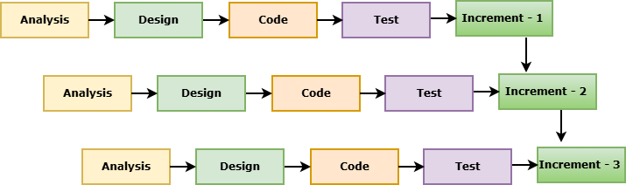

Figure 1.1: Incremental Process Model

Each increment is developed in a generic manner following the cycle shown in the Incremental Process Model:
- Requirement Analysis: Requirements were identified for each increment and prioritized at this stage. For instance, first we developed guardian registration and posting of tuition, then we added tutor application, admin verification process, CV management, and finally, real-time integration with chat using SignalR.
- Design and Development: A modular system design was developed to ensure that the newly developed features could be smoothly incorporated with the existing features. Every increment, like posting of tuition, application of tutors, admin approval, and communication in chat, was implemented separately using ASP. Uses NET Core MVC, Entity Framework Core, and SQL Server for persistence.
- Testing: All new features were thoroughly tested separately before they were added. The individual modules were checked for correct operation by the unit testing, and for correct operation when combined with other components, e.g., tutor applications and admin approval, by the integration testing.
- Implementation: When an increment become stable it was used as a working increment. The users could directly use features like posting tuition requirement, applying for tuition, downloading CVs of tutors or chatting with the admin.
- Feedback: Feedback was gathered after every increment from guardians, tutors and administrators who used the test. Later development stages included ideas like better layouts for tutor profiles, better notifications when tuition posts are approved and simple chat interfaces. The process was repeated until all major modules were supported in this system, such as guardian tuition posting, tutor application and verification, admin approval workflows, CV management, real-time chat, reporting features, and notifications.

1.5 Feasibility Study:
A feasibility study was conducted to assess whether the proposed Design and Implementation of a Multi‑Actor Tuition Management Platform could be realistically developed and implemented. The study looked at three aspects of feasibility: technical feasibility, economic feasibility, and operational feasibility. The results show that the system is feasible and attainable in all three domains.

1.5.1 Technical Feasibility:
Technically, the project is feasible as it is based on well-known and widely used technologies. The system is built using ASP.NET Core MVC for a structured application, Entity Framework Core for database management, and SQL Server for secure data storage and retrieval. SignalR was integrated to enable real-time chat communications to smooth interactions among guardians, tutors, and administrators. The system architecture was designed modularly, so that future expansion, such as adding new features, dashboards or reporting modules, can be performed without affecting core functionality. Moreover, the system does not require any special hardware and can be efficiently operated on standard servers and personal computers, thus allowing its implementation in both academic institutions and private environments.

1.5.2 Economic Feasibility:
The project is economically viable thanks to low costs in development and operation. The system was developed as part of an academic project and there were no external costs of development. Most of the development tools, frameworks and libraries used were open source or available through educational licenses significantly reducing expenses. Hosting and maintenance is cost effective as the system can be hosted on low cost cloud infrastructure or local servers. The digital platform offers a cheaper alternative to traditional tuition management practices involving manual record keeping and physical communication. We also have features like tutor CV downloads and reporting modules which opens avenue for future monetization thus ensuring long term sustainability.

1.5.3 Feasibility of operations:
Operationally, the system is very feasible as it directly answers the needs of guardians, tutors and administrators. Guardians can access tuition posting and communication with administrators immediately while tutors can easily apply for tuition opportunities and show their verified profiles. For admins, a centralized dashboard is provided to manage verification and approvals and communication. This helps in tasks such as user management and system monitoring. During development, user interface testing was done to ensure that it is clear and user friendly even to those who have limited technical skills. The system requires minimal training and is easily scalable for future growth making it practical for long term adoption.

Chapter 2: Organizational Overview

2.1 Organizational Overview:
nTier’s objective is to offer customized solutions for all its customers using software and technological solutions that fit their unique requirements. By leveraging its technical knowledge and focusing on quality, the company delivers solutions that not only address the current problems but also have future value.

2.2 Organization Services:
The Development of Resource Planning project encompasses a diverse range of services,
including:

2.2.1 Core Values
The company culture is guided by three key values:
- Client Focus: Prioritizing customer needs and delivering solutions that align with their strategic goals.
- Integrity: Upholding honesty, accountability, and ethical practices in all operations.
- Excellence: Striving for continuous improvement and maintaining high standards in software development and service delivery.

2.3 Organization Service:
nTier Solutions offers a wide range of services designed to support diverse client requirements:
1. Customized Software Development
- End-to-end turnkey solutions tailored to specific business needs.
- Agile development practices ensuring flexibility and adaptability.
2. Dedicated Resource Outsourcing
- Providing skilled developers and IT professionals who work as in-house resources for clients.
- Seamless integration with client teams to ensure productivity and collaboration.
3. Technology Consulting
- Strategic guidance on digital transformation, system architecture, and process optimization.
- Expertise in modern frameworks, databases, and enterprise solutions.
4. Long-Term Client Partnerships
- Building trust through consistent delivery and reliable support.
- Offering scalable solutions that evolve with client requirements.

2.4 Organization Vision
The vision of nTier Solutions is to become a trusted global technology partner that offers cutting-edge solutions to its clients on an ongoing basis. Their mission is to enable companies to make use of efficient and scalable software and IT services.

2.5 Organization Mission
nTier’s objective is to offer customized solutions for all its customers using software and technological solutions that fit their unique requirements. By leveraging its technical knowledge and focusing on quality, the company delivers solutions that not only address the current problems but also have future value.

2.6 My Position in the Organization:
As an Intern Web Developer, I have had the privilege of working under the guidance of an
experienced and supportive supervisor. His mentorship has been invaluable, allowing me to
acquire substantial knowledge and skills relevant to my role. With his expert direction, I
successfully completed my project on time, learning the importance of time management and
professionalism in the process. Adhering to organizational policies and office hours has
prepared me well for my future career, making this experience truly fulfilling.

2.7 Address of the Organization:
- Headquarters: Sector 7, Uttara, Dhaka 1230, Bangladesh
- Official Website: www.ntiers.net

Chapter 3: Requirement Engineering

Requirement engineering plays a key role in the implementation of the Design and Implementation of a Multi-Actor Tuition Management Platform project. First of all, the main purpose of this stage is to precisely determine what the users need and convert their needs into technical specifications. The proposed system will be focused on solving such problems associated with the private tuition management, such as a lack of transparency during the verification process, ineffective communication between different parties, and the utilization of informal relationships. Using the analysis of the interaction of different actors, this stage will ensure the implementation of a reliable, accessible, and secure digital platform.

In this stage, the following issues were analyzed in detail:

- User Needs Definition: Ensuring guardians' ability to post tuition and tutors' capability to apply by submitting verified profile data.

- System Needs Definition: Providing access to the role-based dashboard and authentication, downloading CVs of tutors, and integrating real-time chat.

- Scalability and Accessibility: Creating a scalable and accessible design of the system.

3.1 Requirement Categories
To provide a structured framework for development, the requirements are categorized into four distinct domains:
- User Requirements
- System Requirements
- Functional Requirements
- Non-Functional Requirements

3.1.1 User Requirements
User requirements delineate the specific expectations and interface needs of the three primary stakeholder groups.
For Guardians:
- Register and manage personal profiles.
- Post tuition requirements with subject, location, and preferred schedule.
- Track approval status of tuition posts.
- Communicate with administrators and tutors via real-time chat.
For Tutors:
- Register and maintain verified profiles.
- Apply for tuition posts and upload academic documents.
- Share downloadable CVs to establish credibility.
- Receive notifications regarding application status.
For Administrators:
- Monitor and manage all user accounts.
- Verify tuition posts and validate tutor credentials.
- Oversee communication between guardians and tutors.
- Generate analytical reports on system performance and engagement.

3.2 System Requirements
System requirements define the technical framework and backend processes necessary to support user functionalities.
- Role-Based Access Control: Differentiated dashboards for guardians, tutors, and administrators.
- Database Management: Entity Framework Core with SQL Server for secure data storage and relationships.
- Verification Workflow: Logic for tutor document validation and tuition post approval.
- Notification System: Real-time updates on application and approval status.
- Communication Module: SignalR hubs for instant chat between actors.

3.3 Functional Requirements
The core operational capabilities of the tuition management platform include:
- Guardian tuition posting and tracking.
- Tutor application submission with document upload.
- Administrative verification and approval workflows.
- Downloadable tutor CVs for guardians.
- Real-time chat communication among all actors.
- Reporting and analytics for system monitoring.

3.4 Non-Functional Requirements
These requirements establish the performance and quality benchmarks for the platform:
- Performance: Tuition posts and applications must be processed within seconds.
- Usability: Intuitive dashboards designed for guardians, tutors, and admins.
- Reliability: Secure storage and backup of tutor documents and tuition records.
- Availability: Deployment across web interfaces with responsive design.
- Integrity: Strict server-side validation and secure authentication mechanisms.

3.5 Use Case Diagram
The Use Case Diagram helps show how the different actors use the tuition management software in order to perform certain tasks. The main actors used for this particular case include the Guardian, Tutor, and Admin. The Use Case Diagram is useful since it acts as the guiding tool in determining the link between these users and the software.
1. Guardian Use Cases:
- Login/Registration
- Post Tuition Requirement
- Track Approval Status
- Communicate with Admin/Tutor via Chat
2. Tutor Use Cases:
- Login/Registration
- Apply for Tuition Posts
- Upload Academic Documents
- Share Downloadable CV
3. Admin Use Cases:
- Manage Users
- Verify Tuition Posts
- Validate Tutor Credentials
- Generate Reports
- Oversee Communication

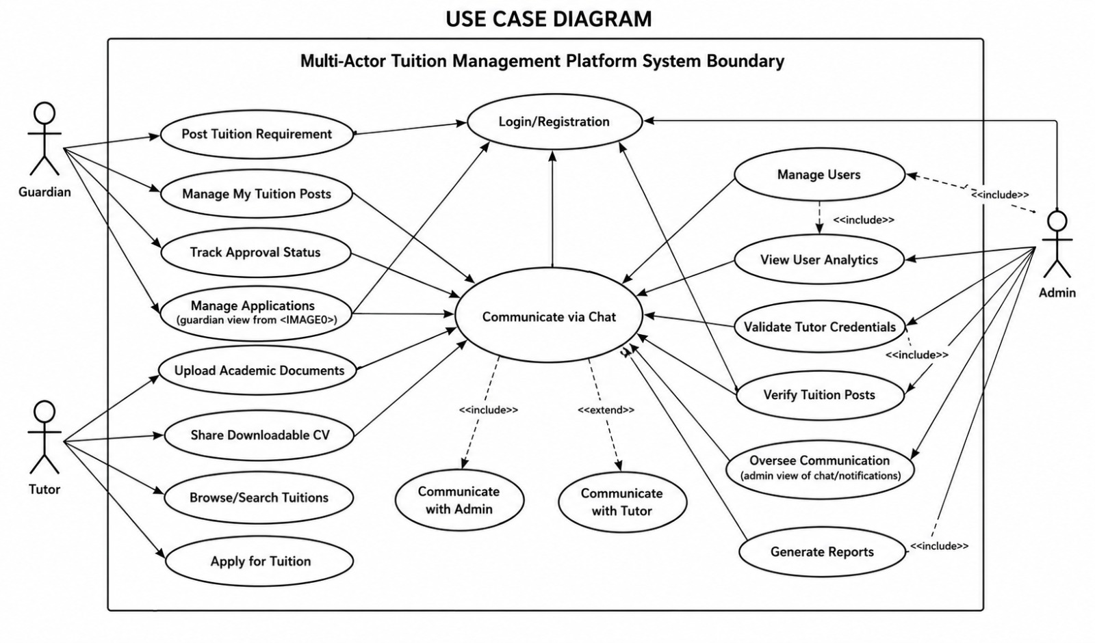
Figure 3.1: Multi-Actor Tuition Management Platform

Chapter 4: Analysis

This chapter describes the analysis phase of the development of a multi-actor tuition management platform. It describes the interrelated swimlane responsibilities for guardians, tutors, and administrators, discusses the selected software analysis pattern, provides stepwise activity flows for critical features such as tuition posting, tutor application, and administrative verification, and defines the class diagram with entities, significant attributes, and relations. All information is written in a formal, academic manner to represent the unique design of the system, and is tailored to the specific features implemented, such as role-based dashboards, credential verification, integrated chat, and automated reporting.

4.1 Software Analysis Pattern
Chosen Pattern: Layered architecture with Service and Repository layers, incorporating specialized role-based access and communication support patterns.
Layers and Responsibilities
- Presentation Layer (Views / Controllers, Frontend):
  - Provides dashboards for Guardians, Tutors, and Admins.
  - Manages user inputs such as tuition posting forms, tutor applications, and credential uploads.
  - Facilitates chat interactions across actors.
  - Controllers orchestrate requests by calling specialized Services and returning results as structured outputs.
- Application / Service Layer:
  - Contains the core business logic (Tuition Management Service, Application Service, Verification Service, Chat Service).
  - Coordinates tutor application workflows and guardian acceptance logic.
  - Enforces system rules such as preventing duplicate applications and ensuring verified credentials before tutor approval.
- Domain / Model Layer:
  - Domain entities include Guardian, Tutor, Admin, TuitionPost, Application, and ChatMessage.
  - Includes data models for tutor verification status, tuition post lifecycle, and communication threads.
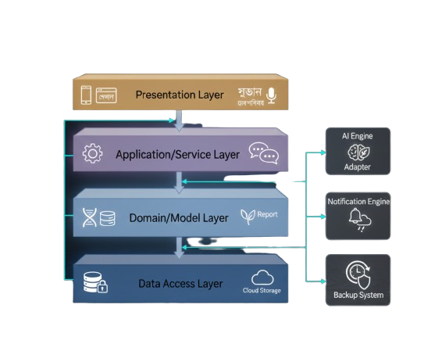
Figure 4.1: Software Analysis Pattern Layer

- Data Access Layer (Repository + EF Core / DB):
  - Repositories provide CRUD and query operations for managing guardians, tutors, admins, tuition posts, and applications.
  - Ensures secure data storage and system integrity through validation and relational constraints.
- Integration / External Interfaces:
  - Notification Engine: Handles alerts for new applications, approvals, and chat messages.
  - Verification Adapter: Interfaces with external document validation services (e.g., ID or certificate checks).
  - Backup System: Automates nightly data backups every 24 hours.

4.2 Activity Diagram

An Activity Diagram is a graphical representation similar to a flowchart that shows the sequence of events within the system. It illustrates the procedures and workflows for different tasks inside the Development of a multi-actor tuition management platform, such as login, post tuition, verify tuition, and admin interaction. Activity diagrams are often used to demonstrate how various users, including tutors, guardians, and students, interact with the system and how the platform logically processes their requests to provide real-time agricultural support.

4.2.1 Activity Diagram for Guardian\Student (User) Registration

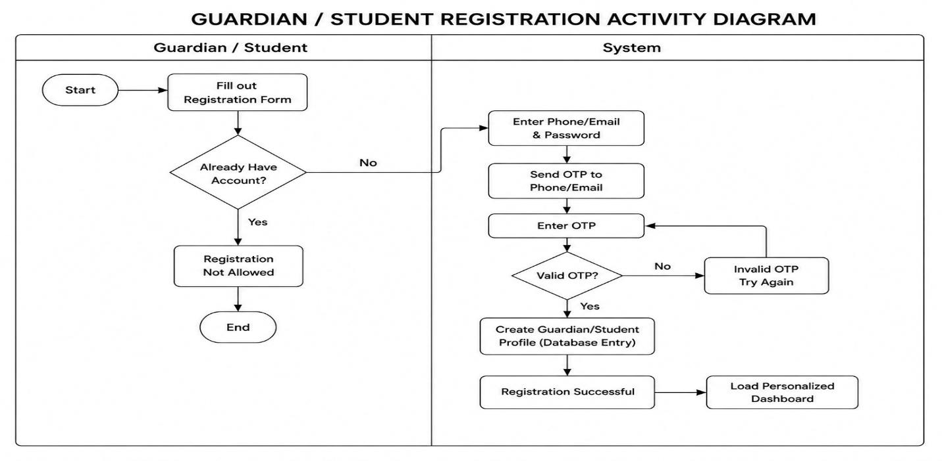
Figure 4.2: Activity Diagram for Guardian\Student Registration

4.2.2 Activity Diagram for Tutor Registration

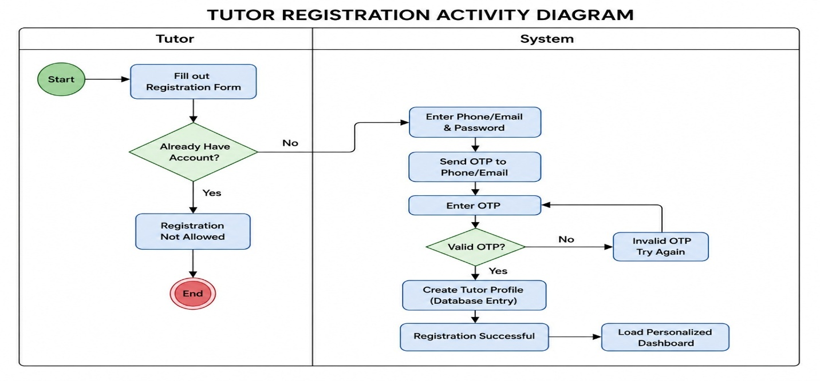
Figure 4.3: Activity Diagram for Tutor Registration

4.2.3 Activity Diagram for Tutor Login

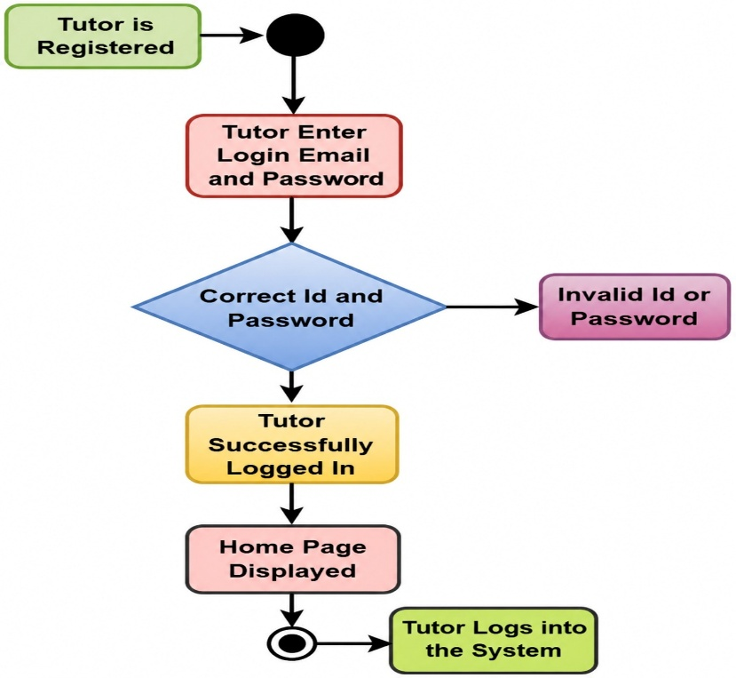
Figure 4.4: Activity Diagram for User Login

4.2.4 Activity Diagram for Guardian/Student Login

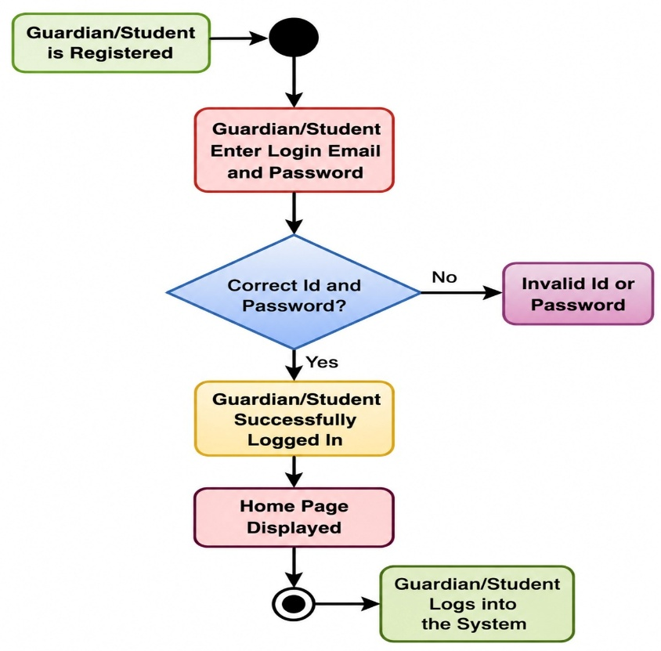
Figure 4.5: Activity Diagram for Guardian/Student Login

4.2.5 Activity Diagram for Admin Login
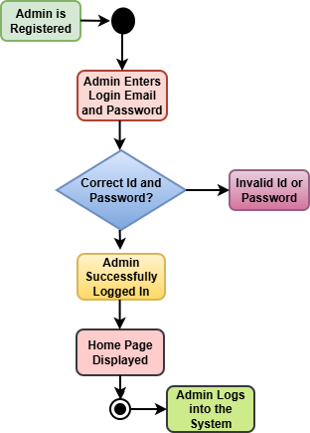

Figure 4.6: Activity Diagram for Admin Login

4.2.6 Guardian/Student Overall Activity Diagram
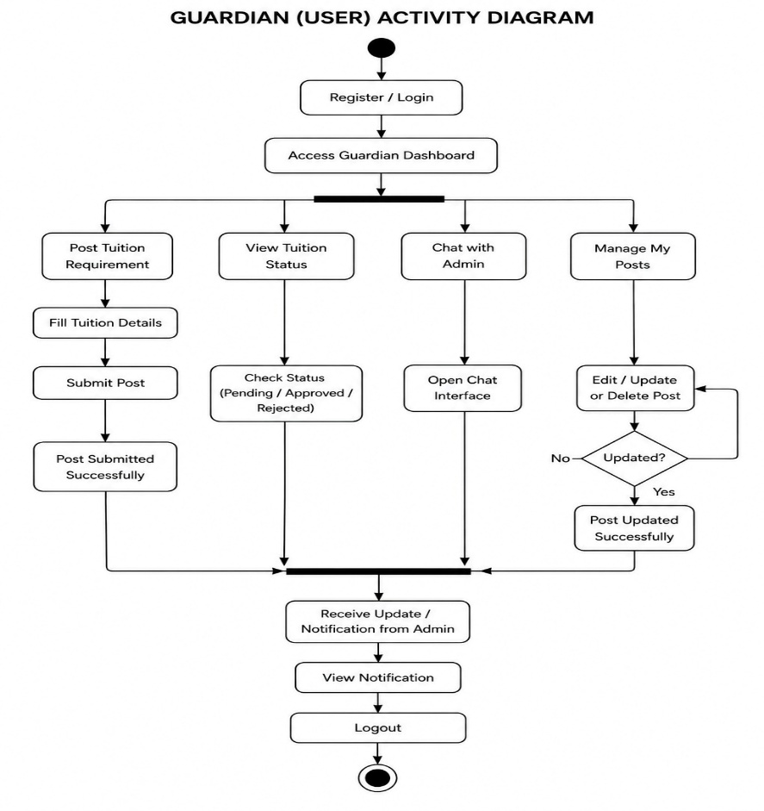
Figure 4.7: Guardian/Student Overall Activity Diagram

4.2.7 Admin Overall Activity Diagram
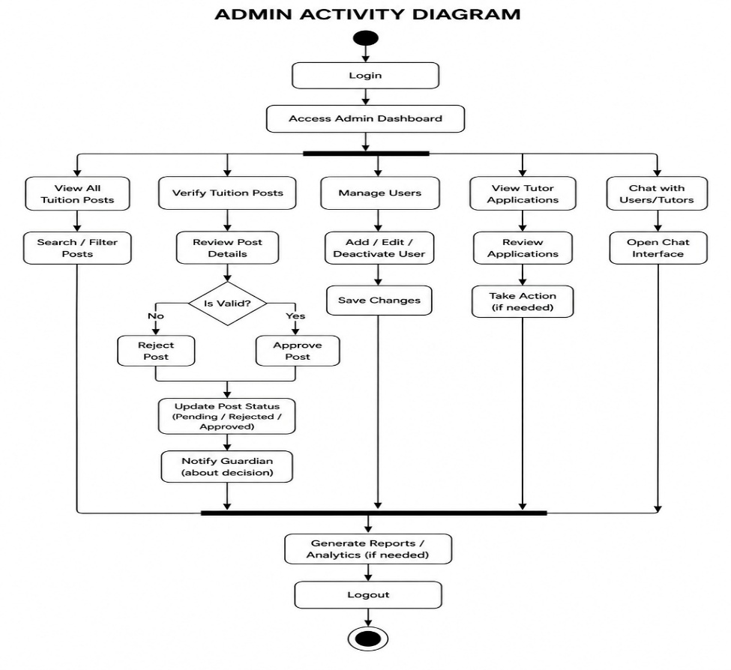
Figure 4.8: Admin Overall Activity Diagram

4.2.8 Tutor Overall Activity Diagram
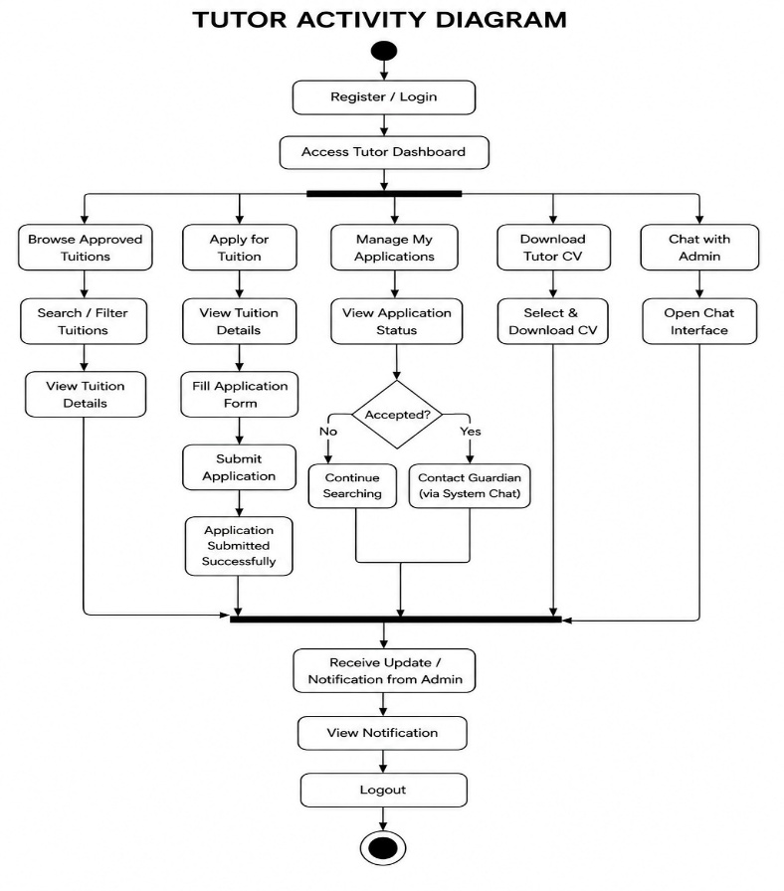
Figure 4.9: Tutor Overall Activity Diagram

4.3 Swimlane Diagram:

The swimlane diagram illustrates the interaction flows among the three primary actors of the Multi-Actor Tuition Management Platform: Guardian, Tutor, and Admin. Each lane represents the responsibilities and actions of a specific actor, while the horizontal flow depicts how tasks move across roles to complete critical processes such as tuition posting, tutor application, and administrative verification.

4.3.1 Swimlane Diagram for Admin

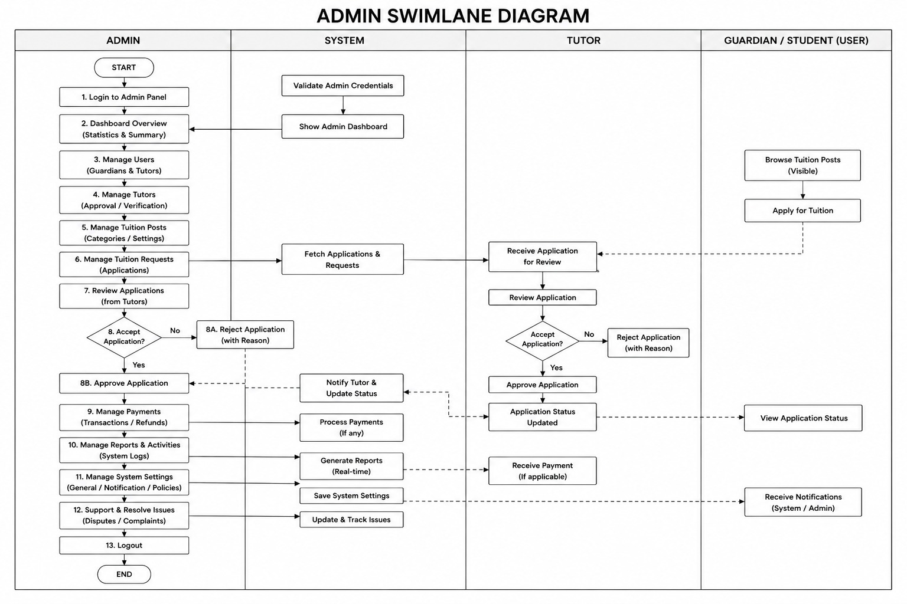

Figure 4.10: Admin Swimlane Diagram

4.3.2 Swimlane Diagram for Tutor

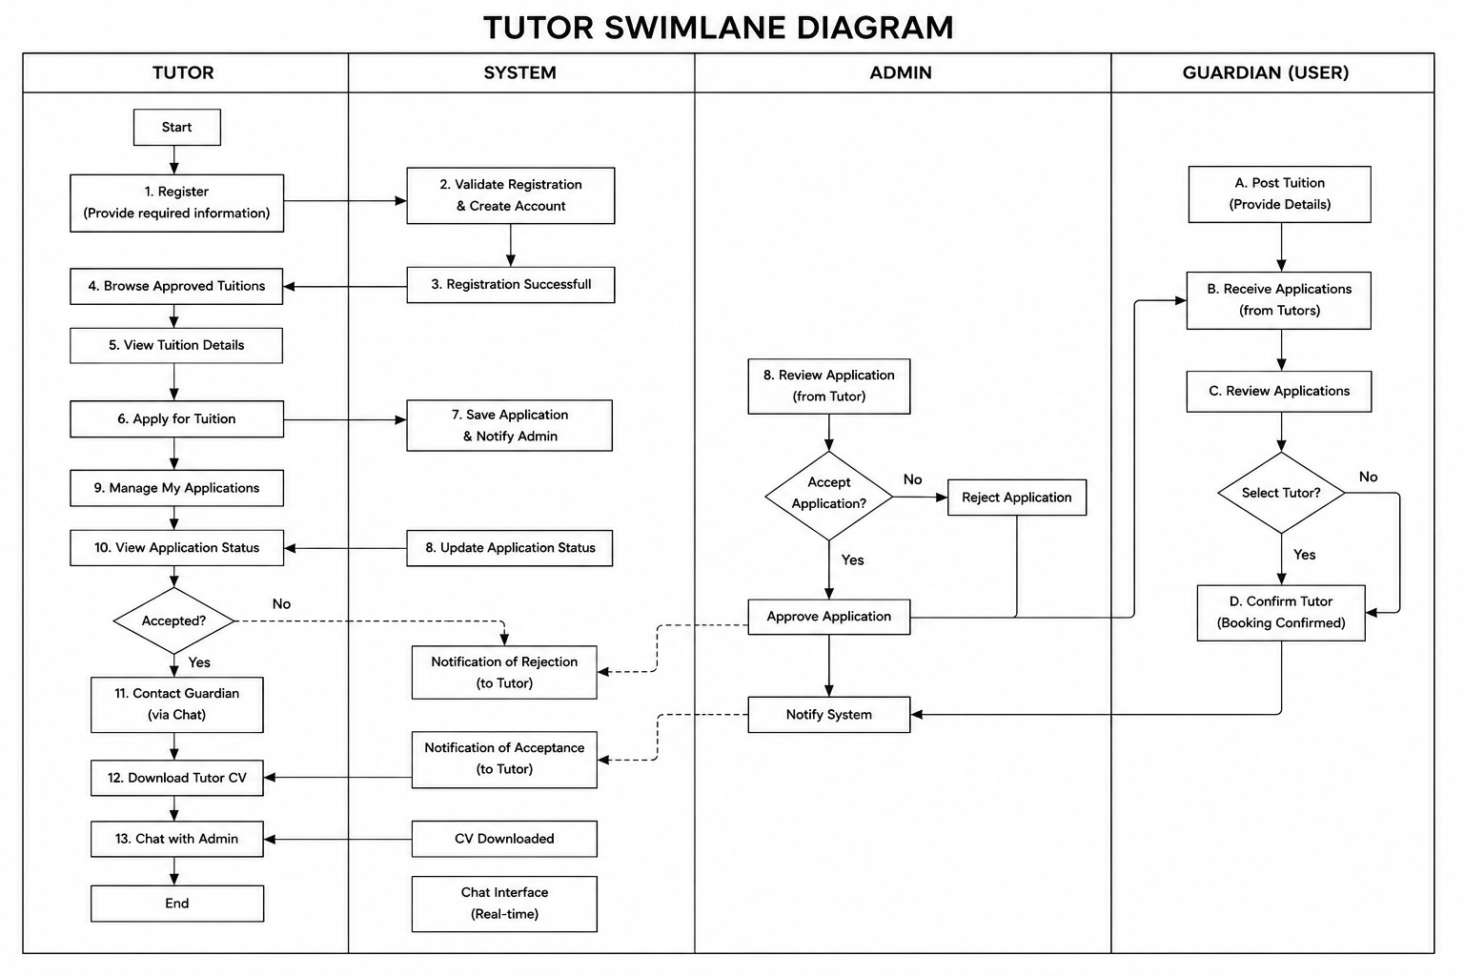
Figure 4.11: Tutor Swimlane Diagram

4.3.3 Swimlane Diagram for Guardian\Student

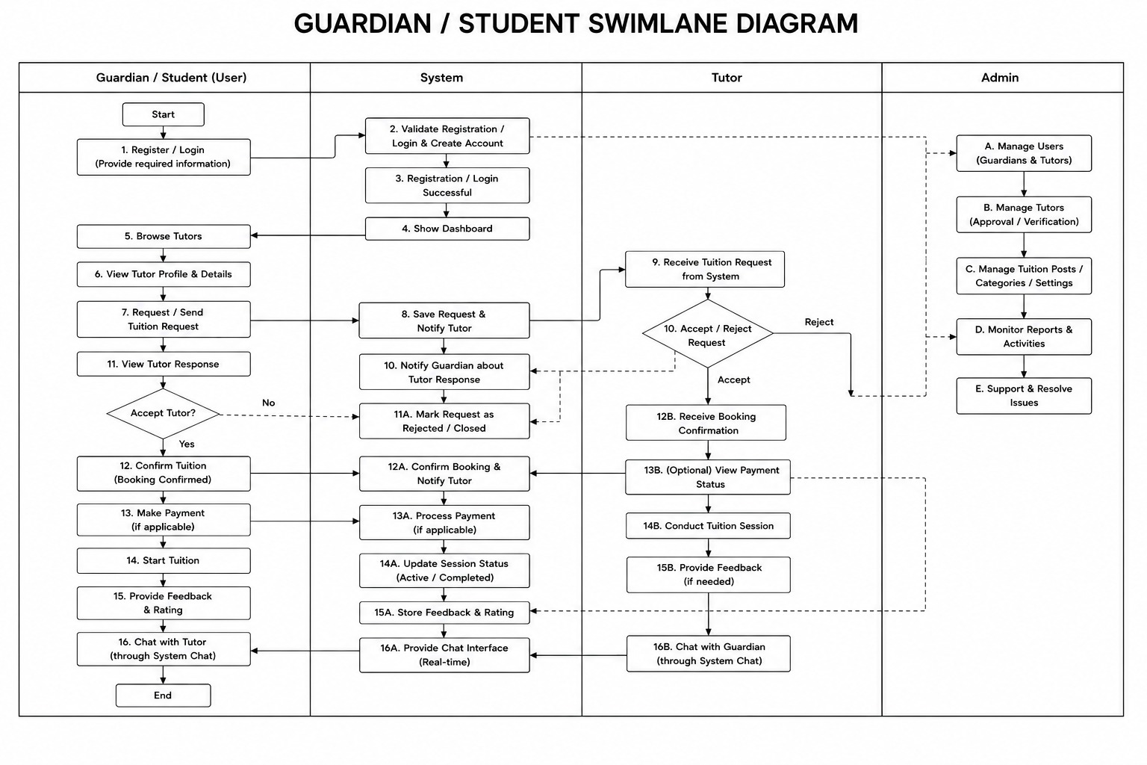
Figure 4.12: Guardian/Student Swimlane Diagram

4.4 Class Diagram
The class diagram represents the static structure of the Multi-Actor Tuition Management Platform, defining the system’s core entities, their attributes, and the relationships among them. It provides a blueprint for how guardians, tutors, and administrators interact with tuition posts, applications, and communication modules.
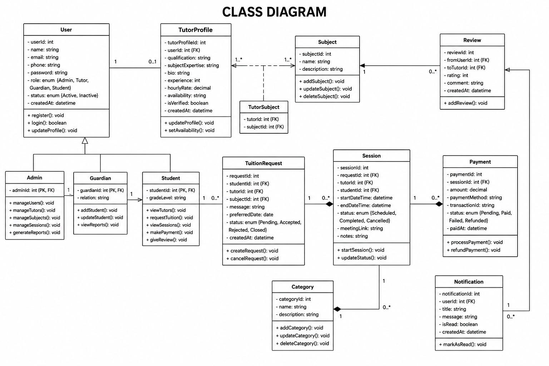
Figure 4.13: Class Diagram

4.5 Sequence Diagram

The sequence diagram illustrates the dynamic behavior of the Multi-Actor Tuition Management Platform, showing how guardians, tutors, and administrators interact with the system components in a time-ordered manner. It highlights the exchange of messages, the invocation of services, and the logical progression of actions required to complete critical workflows.
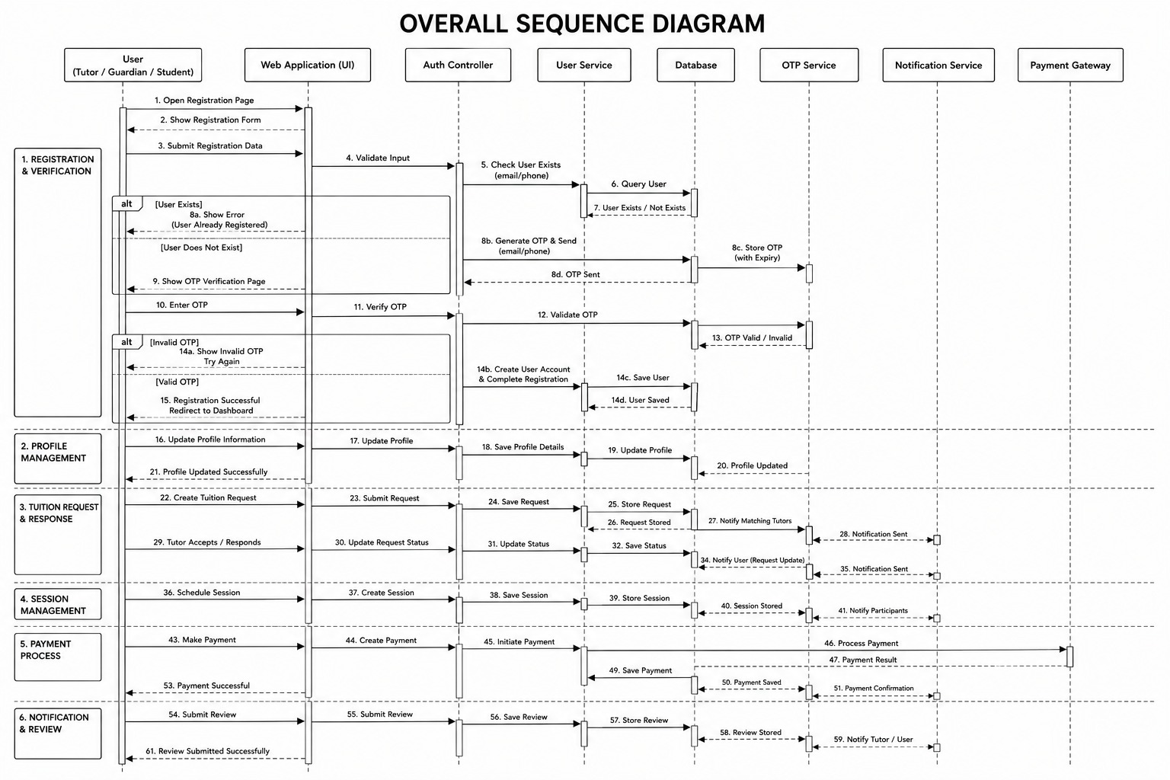

Figure 4.14: Sequence Diagram

Chapter 5: Project Management

The management of this project had an important role in guaranteeing that the development process of the Multi-Actor Tuition Management Platform was completed in accordance with its deadline, budget constraints, and quality requirements. This chapter will discuss the risks experienced during the process of developing the platform, their impact on the success of the venture, and the techniques used to control and track them. Risk management became even more crucial because of the multi-actor nature of the software, the technical difficulties involved in the verification of credentials, and the need to facilitate real-time communication between parents, tutors, and administrators. Through the prediction of possible problems, the project team could effectively manage resources, minimize uncertainties, and make steady progress towards building a dependable tuition management application. Below are the methods of identifying, analyzing, and managing risks, which led to the final RMMM plan.

Table 5.1: Risk Identification Table:
Risk ID | Risk Description | Risk Category
R1 | Unclear or incomplete understanding of multi-actor requirements (Guardian, Tutor, Admin roles) | Requirement Risk
R2 | Compatibility issues with ASP.NET Core, EF Core, and SQL Server integration | Technical Risk
R3 | Database design complexity causing incorrect mapping of tuition posts and applications | Technical Risk
R4 | Tight project timeline impacting the quality of deliverables | Schedule Risk
R5 | Vulnerabilities in credential verification and chat data security | Security Risk
R6 | Slow performance during peak usage (multiple concurrent applications and chats) | Performance Risk
R7 | Limited guidance and delays in decision-making during iterations | Management Risk
R8 | System crashes or bugs during module integration and testing | Development Risk

5.1 Risk Analysis
Risk analysis involves assessing the probability of each risk occurring and its impact on the project. This analysis helps prioritize risks that need immediate attention.

Table 5.2: Risk Analysis Table
Risk ID | Probability | Impact | Risk Level
R1 | Medium | High | High
R2 | Medium | Medium | Medium
R3 | Low | High | Medium
R4 | High | High | High
R5 | Medium | High | High
R6 | Low | Medium | Low
R7 | Medium | Medium | Medium
R8 | Medium | Medium | Medium

5.2 Risk Planning
Proper risk planning ensures that identified risks are addressed proactively. For the Multi-Actor Tuition Management Platform, mitigation strategies were applied to reduce or eliminate risks.

Table 5.3: Risk Planning
Risk ID | Risk Mitigation Strategy
R1 | Conduct thorough requirement gathering with guardians, tutors, and admins; ensure scope clarity and regular reviews of project documentation.
R2 | Select proven, widely used, and adequately documented frameworks/tools to minimize technical difficulties.
R3 | Design a normalized database schema with regular testing and dummy data trials.
R4 | Utilize Agile methodology with short sprints, prioritize critical features, and maintain a progress-focused schedule.
R5 | Adopt security best practices such as SSL, encrypted credentials, and input validation to prevent vulnerabilities.
R6 | Optimize database queries and conduct rigorous load testing to assess performance under heavy usage.
R7 | Use online resources and maintain comprehensive documentation to reduce dependency delays.
R8 | Apply incremental development and early module testing to limit bugs and enable quick resolution.

5.3 The RMMM Plan (Risk Mitigation, Monitoring, and Management)
The RMMM Plan provides a structured approach to addressing risks during the development of the Multi-Actor Tuition Management Platform. It includes measures to anticipate, address, and respond to risks efficiently, ensuring risks are minimized without compromising the project timeline, quality, or results.

5.3.1 Risk Mitigation
- Selection of reliable and well-supported technologies to minimize compatibility issues.
- Regular team discussions for clarifying requirements and reviewing documentation.
- Application of industry-standard coding practices, secure authentication, modular system designs, and robust database structures.
- Load and performance tests conducted early using simulated multi-actor traffic.
- Incremental development was adopted to ensure each module was tested early, limiting bugs and enabling quick fixes.

5.3.2 Risk Monitoring
- Weekly progress reviews to track milestones and detect potential delays.
- Frequent testing of modules during each development stage to identify logical errors, security gaps, and performance bottlenecks.
- Regular peer reviews and supervisor feedback to uncover risks and improve usability/design standards.
- Monitoring key performance metrics such as query response time and scalability under concurrent users.
- Maintaining logs of all changes, updates, and bugs to track recurring patterns and prevent future errors.

5.3.3 Risk Management
- Adjusting development plans and schedules based on progress and unforeseen delays.
- Re-prioritizing critical features and deferring low-priority tasks during time constraints.
- Using debugging tools and logs to identify and fix bugs promptly.
- Performing regression testing after fixes to ensure no new issues were introduced.
- Enabling transparent communication between team members to manage expectations and proactively handle risks.

Chapter 6: Project Planning and Scheduling

To ensure that the Multi-Actor Tuition Management Platform is constructed within the specified time, resource, and quality restrictions, project planning and scheduling are essential. The project's objectives, necessary resources, and team roles for each phase—requirement analysis, design, development, testing, and deployment—are all determined by planning. Effective scheduling ensures timely delivery, avoids resource conflicts, and streamlines the project workflow by organizing these tasks into a timetable with distinct deadlines and milestones.

6.1 System Project Estimation

System project estimation focuses on forecasting the time, resources, and effort required for the development of the Multi-Actor Tuition Management Platform. Accurate estimation helps define the resource management plan, allocate tasks, control costs, and maintain deadlines effectively.

6.1 Transaction Functions
Module Name | Description | Estimated Time (Hours)
User Authentication & Roles | Secure login and role management for Guardian, Tutor, and Admin roles | 20
Tuition Post Management | Create, update, delete, and categorize tuition posts with subject and location | 35
Tutor Application Handling | Tutors apply for posts, update application status, and track outcomes | 30
Credential Verification | Admin verifies tutor credentials and approves/rejects applications | 25
Chat and Communication | Real-time messaging between Guardian, Tutor, and Admin | 27
Guardian Dashboard | Tuition monitoring, application tracking, and communication | 28
Tutor Dashboard | Tuition browsing, application submission, and credential upload | 22
Admin Dashboard | User verification, post approval, and reporting | 18
Security & Session Management | Authentication, password hashing, and secure logout | 10
Total Estimated Time | 215 Hours

6.2 Functional-Oriented Metrics
Function-oriented metrics evaluate the size and complexity of the software system based on its functionality. It measures the system in terms of user-visible features and establishes effort estimation without relying on detailed design or coding knowledge.
- External Inputs (EI): Login credentials, tuition post creation, tutor applications, credential uploads.
- External Outputs (EO): Application results, verification reports, notifications.
- External Inquiries (EQ): Searching tuition posts, checking application status.
- Internal Logical Files (ILF): Guardian records, tutor profiles, tuition posts, applications, chat messages.
- External Interface Files (EIF): Integration with external verification services or notification APIs.

6.3 Identifying Complexity

6.3.1 Transaction Functions

Function Type | DET | FTR | Count | Complexity | FP
User Login & Role Assignment (EI) | 8 | 2 | 1 | Low | 3
Tuition Post Creation (EI) | 14 | 3 | 1 | Average | 4
Tutor Application (EI) | 16 | 3 | 1 | Average | 4
Tuition Search (EQ) | 9 | 2 | 1 | Low | 3
Credential Verification (EO) | 18 | 4 | 1 | Average | 5
Application Status Report (EO) | 12 | 2 | 1 | Average | 3
Application Tracking (EQ) | 12 | 3 | 1 | Average | 4
Admin Reporting (EQ) | 14 | 3 | 1 | Average | 4
Total Function Points |  |  |  |  | 30 FP

6.3.2 Data Functions
Data Function | Type | DET | RET | Count | Complexity | FP
Guardian Records | ILF | 15 | 4 | 1 | Average | 7
Tutor Profiles | ILF | 20 | 5 | 1 | High | 10
Tuition Posts | ILF | 16 | 4 | 1 | High | 10
Applications | ILF | 10 | 3 | 1 | Average | 7
Chat Messages | ILF | 12 | 3 | 1 | Low | 5
Verification Reports | ILF | 9 | 2 | 1 | Average | 7
Total Function Points |  |  |  |  |  | 41 FP

6.4 Unadjusted Function Point Contribution
- Transaction Functions: 30 FP
- Data Functions: 41 FP
- Final UFP = 71 FP

6.5 Performance and Environmental Impact
Performance Considerations:
- Fast response times for tuition posting, application submission, and chat.
- Scalability to handle multiple guardians, tutors, and admins simultaneously.
- Optimized queries for tuition posts and applications.
- Secure credential verification and encrypted communication.

Environmental Considerations:
- Paperless tuition management (digital applications and reports).
- Remote accessibility for guardians and tutors.
- Energy-efficient hosting solutions.
- Reduced carbon footprint through digital communication and reporting.

6.6 Adjusted Function Point Contribution
- Total Influence Rating (∑Fi): 30
- Technical Complexity Factor (TCF):
0.65 + (0.01 × 30) = 0.95
- Adjusted Function Point (AFP):
71 × 0.95 = 67.45 ≈ 67 FP
- Effort Estimation (Person-Hours):
67 × 10 = 670 hours

6.7 Project Schedule Chart
Phase | Task | Duration (Days)
Planning |  | 7
Analysis |  | 7
System Design |  | 10
Backend Development |  | 25
Frontend Development |  | 15
System Integration |  | 8
Testing | Unit testing, functional testing, and bug fixing | 10
Deployment | Hosting setup, domain integration, and system launch | 5
Documentation | Project reporting and client documentation | 8
Total Duration |  | 85 Days (~3 Months)

6.8 Project Cost Estimation
Table 6.8.1 Personnel Cost
Item | Description | Cost(TK)
Developer (Self) | System design, development, testing (approx. 3 months) | 21,000
Testing Contributor | Assistance in review, testing, and debugging | 3500
Total Hardware Costs |  | 24,500 Tk

Table 6.8.2 Expected Hardware Cost
Item | Description | Cost(TK)
Personal Computer | Existing PC used for development | 00
Internet Access | Monthly broadband package during the 3 months of development. | 3000
Data Backup | Cloud storage or external hardware | 1500
Total Hardware Costs |  | 4500 Tk

Table 6.8.3 Expected Software Cost
Item | Description | Cost(TK)
Code Editor | Domain and hosting solutions (1-year plan) | 00
Frameworks | Power & utilities during development | 00
Database System | Printing and binding final deliverables | 00
Total Software Costs |  | 00 Tk

Table 6.8.4 Expected Other Costs
Item | Description | Cost(TK)
Domain & Hosting | Domain and hosting solutions (1-year plan) | 5,200
Electricity | Power & utilities during development | 1400
Documentation | Printing and binding final deliverables | 1200
Miscellaneous | Unexpected expenses | 1,000
Total Other Costs |  | 7,800 Tk

Total Project Cost = 24,500 + 4,500 + 0 + 7,800 = 36,800 Tk

This estimation represents the total cost, time, and resources required for the successful completion of the Multi-Actor Tuition Management Platform.

Chapter 7: Interface Design

7.1 Interface Design

7.1.1 Homepage:

Figure 7.1: Homepage

7.1.2 Tution postings on the homepage:


Figure 7.2: Tution postings on the homepage

7.1.3 Login page
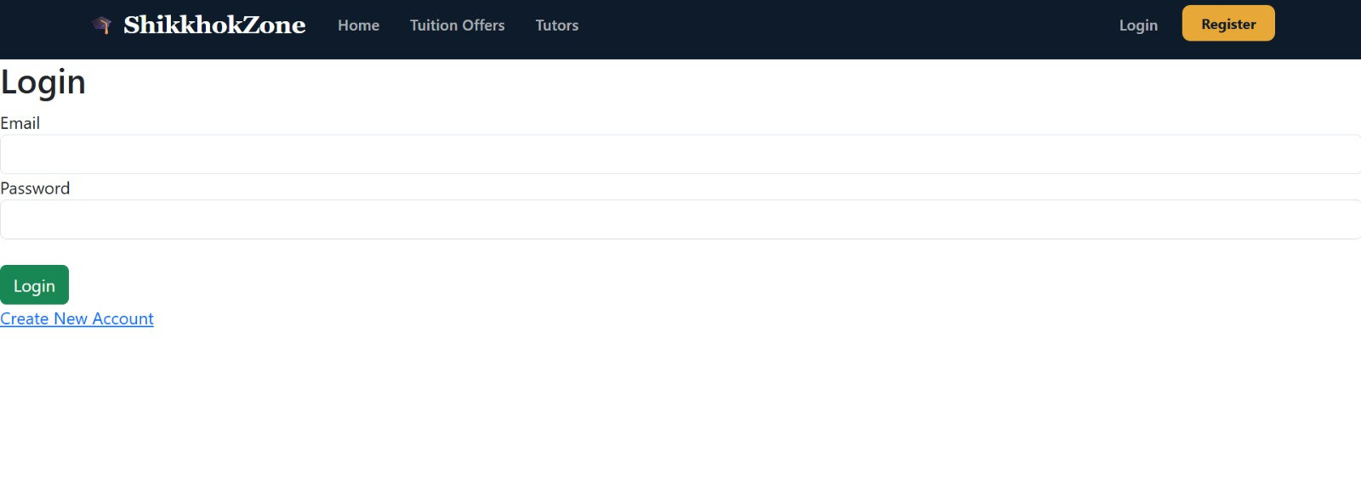
Figure 7.3: Login Page

7.1.4 Registration page
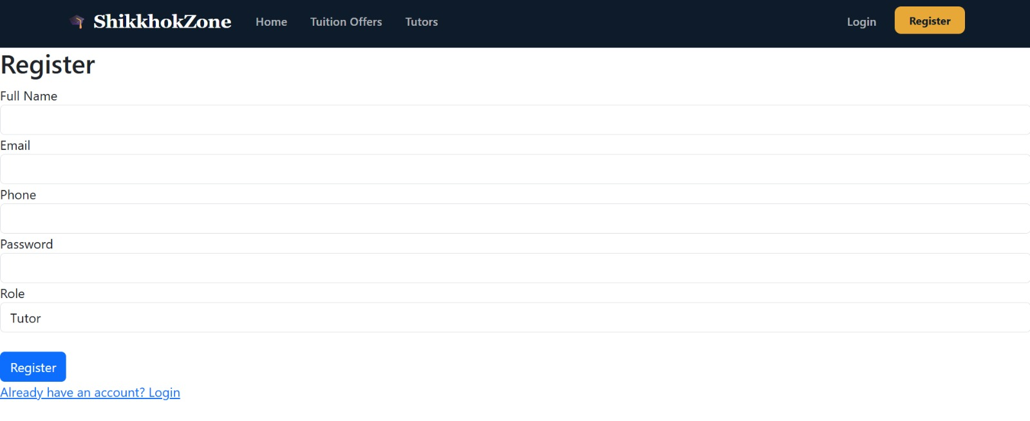
Figure 7.4: Registration page

7.1.5 Guardian Dashboard
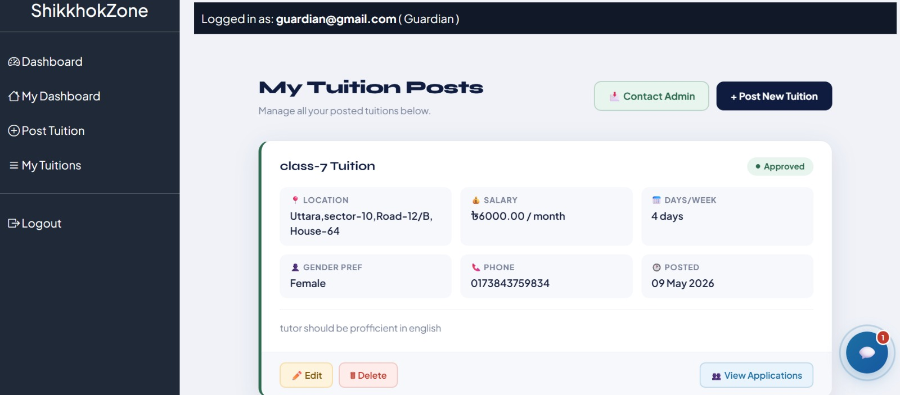
Figure 7.5: Guardian Dashboard

7.1.6 Admin Dashboard



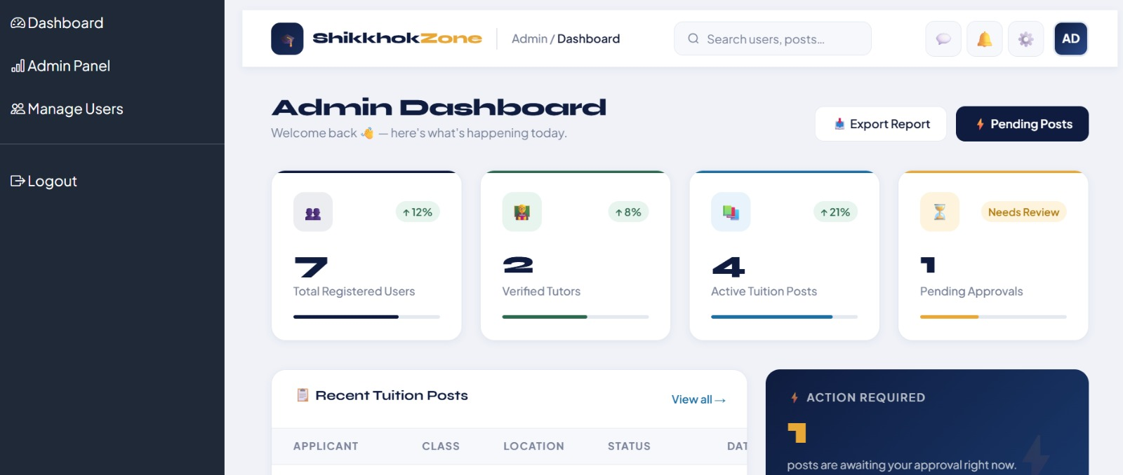
Figure 7.6: Admin Dashboard

7.1.7 Admin Dashboard-2
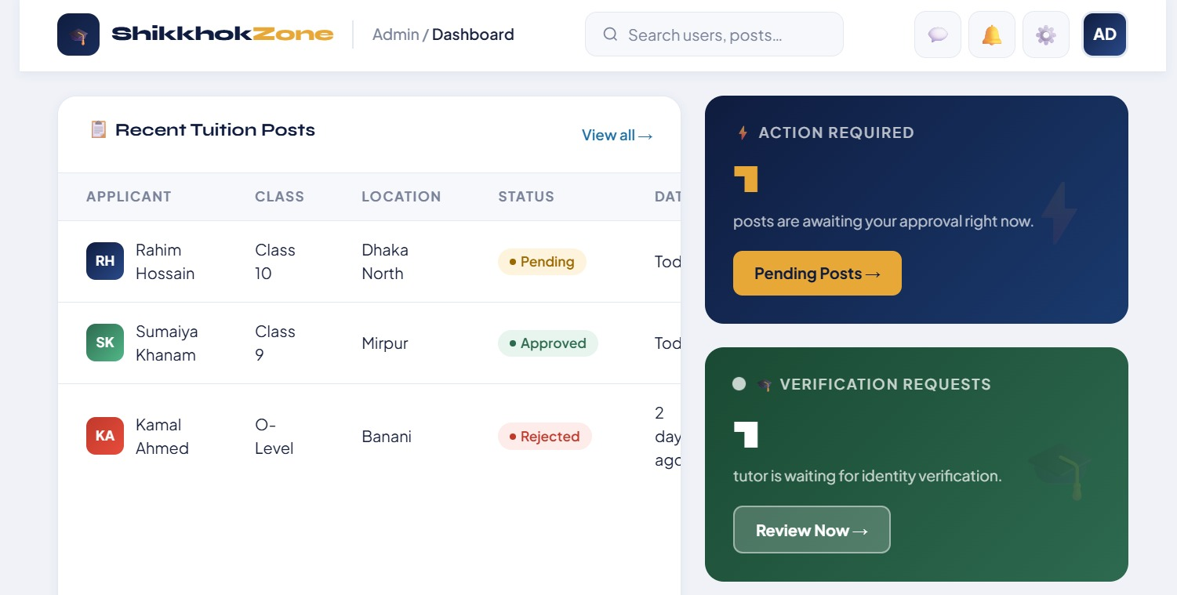

Figure 7.6: Admin Dashboard-2

7.1.8 Approved Tuition posts

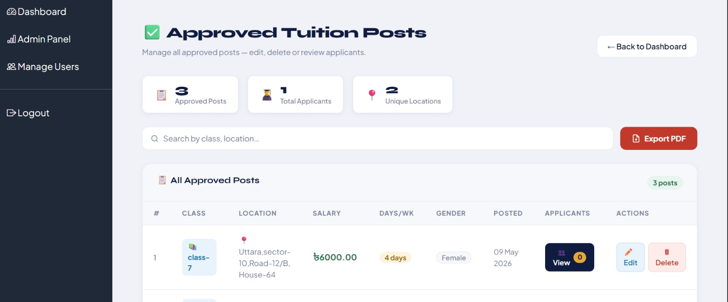
Figure 7.7: Approved Tuition posts

7.1.9 Pending posts
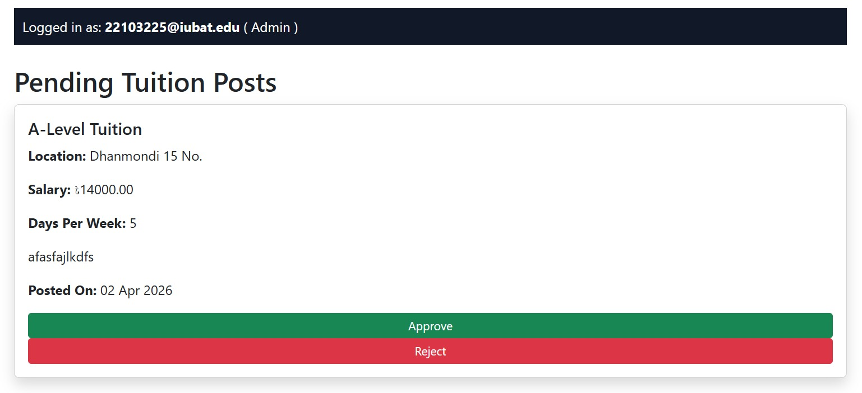
Figure 7.8: Pending posts

7.1.10 Tutor Dashboard

Figure 7.9: Tutor Dashboard

7.1.11 Tutor profile (with verification status)
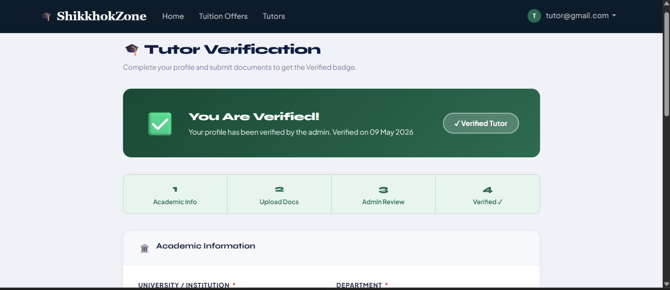
Figure 7.9: Tutor profile (with verification status)

7.2 Database

7.3 Data Flow Diagram
The Data Flow Diagram illustrates the logical flow of data within the Multi-Actor Tuition Management Platform. It highlights how information is captured, processed, and stored across different modules, ensuring transparency and efficiency in system operations. The DFD is divided into levels to show both high-level and detailed interactions.

7.3.1 Context level (Level 0)
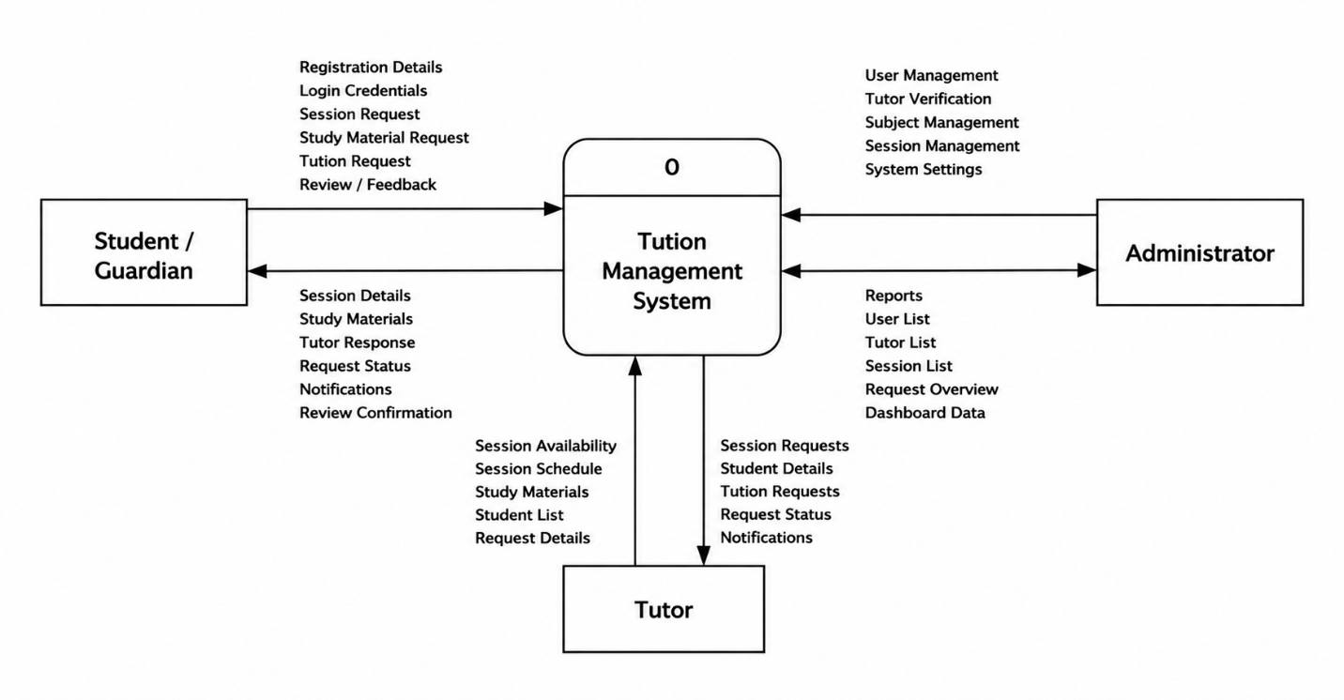

7.3.2 Level 1
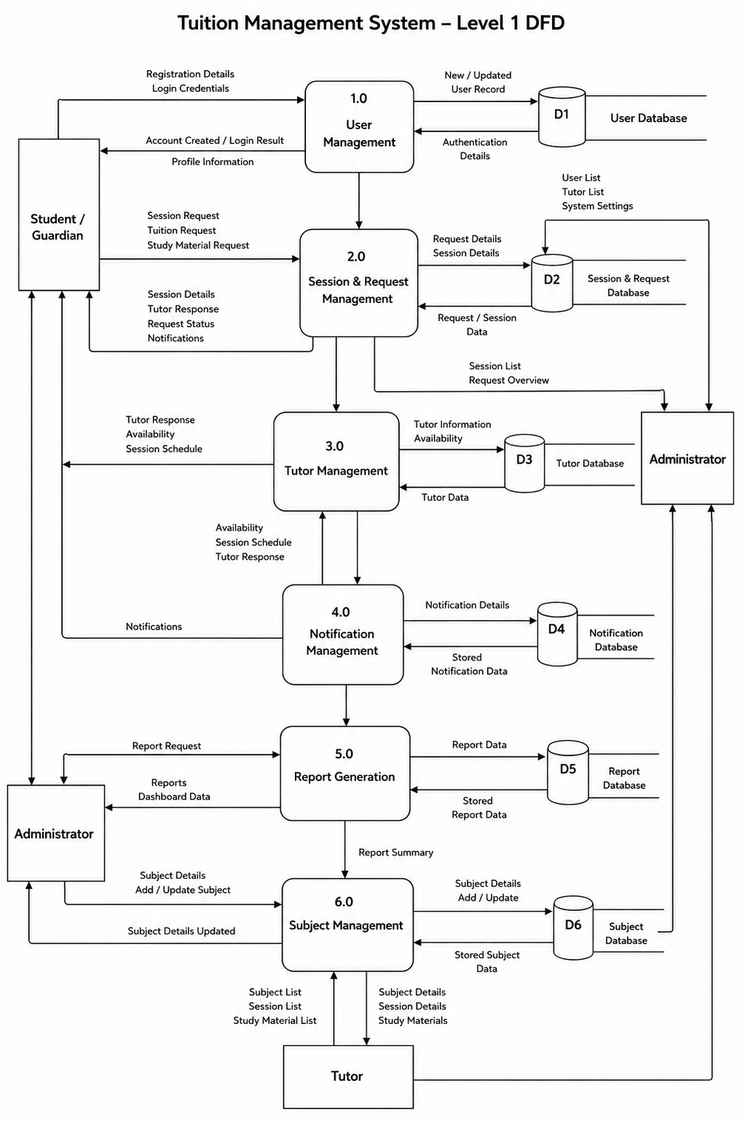

7.3.3 Level 2 Process 1
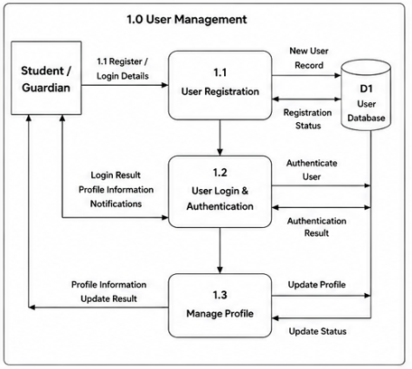

7.3.4 Level 2 Process 2

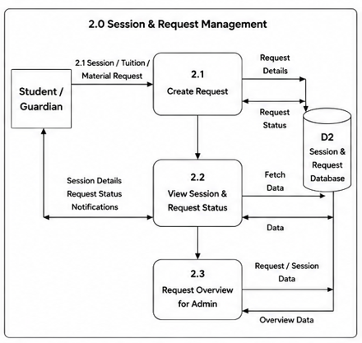

7.3.5 Level 2 Process 3

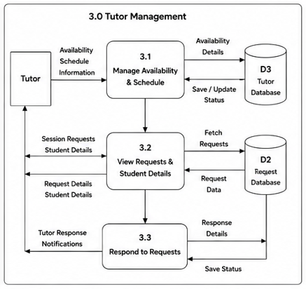

7.3.6 Level 2 Process 4

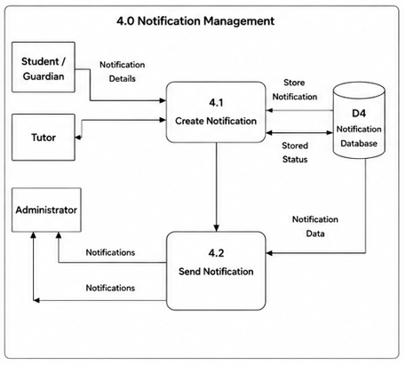

7.3.7 Level 2 Process 5
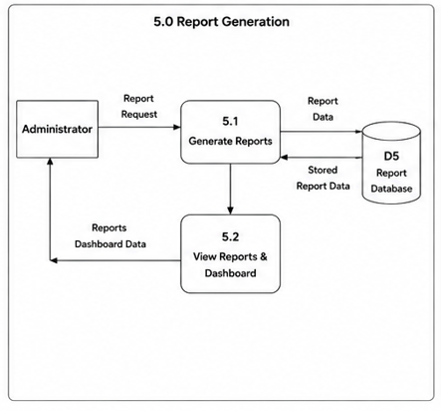

7.3.8 Level 2 Process 6

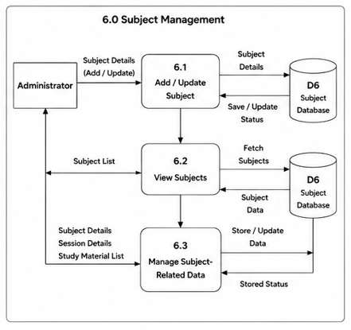

7.4 ERD Diagram
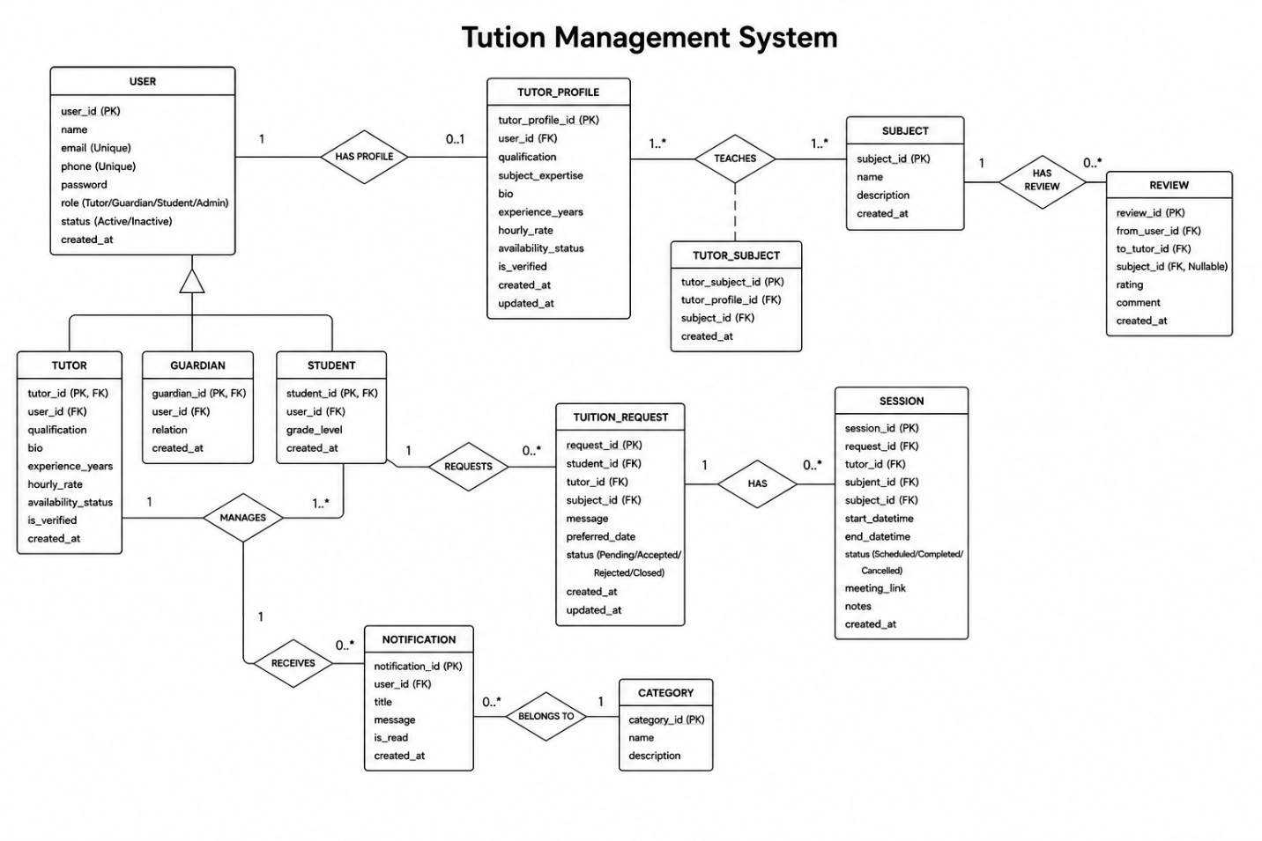

Chapter 8: System Quality and Testing

8.1 Software Quality Management Process
The following actions were implemented as part of the Multi-Actor Tuition Management Platform’s software quality management process to ensure a high-quality final product:
- Requirement Verification: Verified that all functional and non-functional requirements (e.g., role-based authentication, tuition posting, tutor application, credential verification, and real-time chat) were clear, achievable, consistent, and quantifiable before development began.
- Code Quality Control: Ensured clean, maintainable, and error-free code by adhering to coding standards and using best practices in technologies such as ASP.NET Core, C#, JavaScript, and SQL Server.
- Testing Activities: Conducted thorough unit testing, integration testing, and user acceptance testing (UAT) on key modules such as authentication, tuition post management, tutor application handling, credential verification, and chat communication.
- Issue Management: Proactively identified, documented, evaluated, and resolved defects during testing stages. This ensured system reliability and stability for Guardians, Tutors, and Admins.

8.2 Software Test Cases
Below are five sample test cases focusing on the main modules of the Multi-Actor Tuition Management Platform.

Test Case 1: User Login (Guardian/Tutor/Admin)
Test Case ID: TC001
Test Priority: High
Precondition: User accounts must already exist in the system.
Module Name: Authentication
Description: Verify that registered users can log in with valid credentials.
Dependencies: None
Table 8.1: Test Case 1 – User Login
Step | Test Steps | Test Data | Expected Result | Actual Result | Status
1 | Open the system and go to the login page | N/A | Login page loads properly | As expected | Pass
2 | Enter email/username | user@example.com | Input accepted | As expected | Pass
3 | Enter password | N/A | Input accepted | As expected | Pass
4 | Verify role-based access | N/A | User redirected to dashboard | As expected | Pass

Test Case 2: Create Tuition Post (Guardian)
Test Case ID: TC002
Test Priority: High
Module Name: Tuition Post Management
Description: Verify that guardians can create a new tuition post.
Precondition: Guardian must log in.
Dependencies: None
Table 8.2: Test Case 2 – Create Tuition Post
Step | Test Steps | Test Data | Expected Result | Actual Result | Status
1 | Navigate to Guardian Dashboard | N/A | Dashboard loads successfully | As expected | Pass
2 | Click "Create Tuition Post" | N/A | Tuition posts displayed | As expected | Pass
3 | Enter tuition details | Subject: Math, Location: Dhaka | Data validated successfully | As expected | Pass
4 | Save tuition post | N/A | Tuition post added to the database | As expected | Pass

Test Case 3: Apply for Tuition (Tutor)
Test Case ID: TC003
Test Priority: High
Module Name: Application Handling
Description: Verify that tutors can apply for tuition posts.
Precondition: Tutor must log in.
Dependencies: Tuition post must exist.
Table 8.3: Test Case 3 – Apply for Tuition
Step | Test Steps | Test Data | Expected Result | Actual Result | Status
1 | Navigate to Tutor Dashboard | N/A | Dashboard loads successfully | As expected | Pass
2 | Browse tuition posts | Subject: Math | Tuition posts displayed | As expected | Pass
3 | Submit application | TutorID: 102 | Application recorded | As expected | Pass
4 | Verify application status | N/A | Status updated to "Pending" | As expected | Pass

Test Case 4: Verify Tutor Credentials (Admin)
Test Case ID: TC004
Test Priority: High
Module Name: Credential Verification
Description: Verify that admins can validate tutor credentials.
Precondition: Tutor must have uploaded credentials.
Dependencies: The Tutor application must exist.
Table 8.4: Test Case 4 – Verify Tutor Credentials
Step | Test Steps | Test Data | Expected Result | Actual Result | Status
1 | Navigate to Admin Dashboard | N/A | Dashboard loads successfully | As expected | Pass
2 | Open tutor application | TutorID: 102 | Application details displayed | As expected | Pass
3 | Review credentials | CV.pdf | Credentials validated | As expected | Pass
4 | Approve tutor | N/A | Tutor status updated to "Verified" | As expected | Pass

Test Case 5: Chat Communication (Guardian ↔ Tutor)
Test Case ID: TC005
Test Priority: Medium
Module Name: Chat Service
Description: Verify that guardians and tutors can exchange messages.
Precondition: Both must be logged in.
Dependencies: Tuition post and application must exist.
Table 8.5: Test Case 5 – Chat Communication
Step | Test Steps | Test Data | Expected Result | Actual Result | Status
1 | Guardian opens chat | N/A | Chat window loads | As expected | Pass
2 | Tutor sends a message | "Hello, I am interested." | Message delivered | As expected | Pass
3 | Guardian replies | "Please share your CV." | Reply delivered | As expected | Pass
4 | Verify chat history | N/A | Conversation stored in the database | As expected | Pass

Chapter 9: Ethical Consideration

9.1 Ethical Considerations in the Software Development Process

The Multi-Actor Tuition Management Platform was developed with the utmost focus on ethical principles to ensure privacy, fairness, and responsibility toward all stakeholders. Adhering to responsible software engineering practices, the project promotes trust, fairness, and security for all users, including guardians, tutors, students, and administrators.

9.1.1 Data Privacy and Security
The platform ensures data privacy and security to build trust and system reliability. Sensitive information such as user credentials, tutor CVs, and communication records is secured using safe authentication mechanisms and role-based access control.
- Users can only access features and data relevant to their roles (Guardian, Tutor, Admin).
- Input validation and session management mitigate risks like unauthorized access, data breaches, and manipulation.
- Passwords are securely stored using standardized hashing and encryption methods.
- Chat messages and tutor verification documents are protected with secure storage and access policies.
- Regular vulnerability checks and penetration testing ensure resilience against evolving threats.

9.1.2 Intellectual Property
The development of the platform adheres to intellectual property laws and ethical coding practices.
- All system components, including source code, database structures, UML diagrams, and documentation, were explicitly created for the project or adapted from open-source resources with proper attribution.
- The project avoided copyright violations of proprietary software, images, and third-party content.
- By upholding intellectual property rights, the project ensures originality, legal compliance, and academic integrity.

9.1.3 User Impact
The platform provides multiple benefits to its users:
- Guardians: Gain easy access to a user-friendly dashboard for posting tuition requests, reviewing tutor applications, and communicating securely.
- Tutors: Benefit from streamlined application processes, verified credential management, and direct communication with guardians.
- Admins: Manage tutor verification, tuition post approvals, and system monitoring with reduced manual effort. Overall, the system improves user experience by offering seamless operations, reducing errors, and digitalizing tuition management processes.

9.1.4 Bias and Fairness
The platform prioritizes fairness and unbiased approaches in its design to ensure equal treatment for all users.
- Role-based access control assigns permissions strictly based on roles (Guardian, Tutor, Admin).
- All tutors are evaluated using consistent credential verification standards.
- Automated processes (application submission, verification, notifications) minimize human bias and ensure transparent rules.
- Guardians receive equal access to tutor applications without favoritism, and tutors are treated fairly in application reviews.

9.1.5 Responsibility to Stakeholders
The platform was developed to meet responsibilities toward its stakeholders:
- Guardians: Ensuring privacy, accurate tuition information, and timely application handling builds trust and satisfaction.
- Tutors: Providing efficient tools for profile creation, application submission, and communication streamlines their responsibilities.
- Admins: Offering secure and scalable system operations, well-maintained documentation, and compliance with ethical practices ensures long-term sustainability. The system fosters accountability, trust among users, and long-term loyalty for the tuition management service

9.1.6 Professional Responsibility
Throughout development, professional responsibility was upheld by following software engineering best practices and ethical guidelines.
- Writing maintainable and efficient code using standard practices.
- Conducting comprehensive testing to identify and resolve defects promptly.
- Producing well-structured documentation.
- Ensuring clear and transparent communication with stakeholders during project development. The project adhered to academic integrity, professional standards, and ethical considerations, ensuring a well-structured and ethically sound software solution.

9.2 Sustainability in the Software Development Process

9.2.1 Economic Sustainability
The platform was designed to ensure economic sustainability by maximizing efficiency while minimizing costs.
- Reliance on open-source technologies (ASP.NET Core, EF Core, SQL Server Express) reduced development expenditures.
- Digitalizing tuition management reduces operational costs by automating application handling, verification, and reporting.
- Scalable architecture supports future growth without significant hardware or software overhauls.

9.2.2 Social Sustainability
The platform promotes social sustainability by fostering equitable access, reducing manual effort, and promoting smooth digital interactions.
- Guardians, tutors, and admins can conveniently access the system remotely, saving time and effort.
- The platform treats all users fairly, ensuring equity in access to information, applications, and verification processes.
- Accurate application tracking and user-friendly interfaces promote trust and satisfaction.
- By promoting digital communication, the system reduces reliance on paper records and physical interactions, aligning with sustainable technology practices.

The Multi-Actor Tuition Management Platform exemplifies ethical, professional, and sustainable software development practices while respecting privacy, security, fairness, and stakeholder responsibilities. It ensures a better user experience, operational efficiency, and long-term sustainability while strictly adhering to academic integrity and ethical principles. By upholding transparency, accountability, and inclusivity, the system fosters trust among guardians, tutors, and administrators, supporting its role as a reliable and socially responsible digital solution for tuition management.

Chapter 10: Conclusion

10.1 Brief Overview of the Project

The Multi-Actor Tuition Management Platform is a web-based solution designed to simplify and streamline tuition management for Guardians, Tutors, and Administrators. Guardians can post tuition requirements, review tutor applications, and communicate securely. Tutors can register, upload credentials, apply for tuition posts, and interact with guardians. Administrators oversee tutor verification, approve tuition posts, and monitor system integrity.
The system was developed using modern web technologies and a structured software development lifecycle. It ensures accurate data management, secure authentication, and efficient communication. By automating essential tuition processes, the platform reduces manual effort, improves accuracy, and provides a seamless user experience.

10.2 Proposed System Benefits
The Multi-Actor Tuition Management Platform offers the following benefits:
- Guardians: Centralized management of tuition posts, tutor applications, and communication, making the process more efficient.
- Tutors: Streamlined application submission, verified credential management, and direct communication with guardians.
- Admins: Tools for tutor verification, tuition post approval, and reporting, reducing manual workload and ensuring system reliability.
- Students (optional extension): Improved access to verified tutors and transparent tuition management.
The system eliminates manual processes, promotes efficiency, improves end-user satisfaction, and ensures transparency in managing tuition services.

10.3 Limitations of the Project
While the platform meets its primary objectives, the following limitations exist in the current version:
- The system is designed for small- to mid-scale tuition management; handling large-scale traffic requires further optimization.
- Advanced security features, such as multi-factor authentication, are not yet fully implemented.
- The current platform is web-based and lacks a dedicated mobile application, limiting usability for mobile-first users.
- Features such as advanced analytics, AI-based tutor recommendations, and detailed guardian feedback analysis are not included in this version.
These limitations provide opportunities for future improvements to enhance scalability, usability, and security.

10.4 Practicum and Its Value
The practicum for the Multi-Actor Tuition Management Platform was a vital learning experience, bridging theoretical knowledge with practical application. It allowed hands-on experience in system architecture design, database modeling, business logic implementation, and testing system functionality.
Real-world challenges such as debugging, resolving integration issues, optimizing performance, and refining requirements based on feedback were addressed. Professional skills such as time management, adherence to ethical standards, project documentation, and decision-making were refined, preparing the developer for future projects in software engineering. Overall, the practicum was instrumental in building technical readiness and professional growth for future career challenges.

10.5 Future Plans
The Multi-Actor Tuition Management Platform has significant potential for future development and expansion. Proposed enhancements include:
- Mobile Application Development: A dedicated mobile app to improve accessibility for guardians and tutors.
- Cloud-Based Deployment: Migrating to a cloud platform to enhance scalability, security, and performance.
- Smart Features: Advanced analytics for tutor performance and AI-powered tutor recommendations to improve decision-making.
- Advanced Security Features: Implementation of multi-factor authentication, advanced encryption, and fraud detection for better protection of user data.
These enhancements aim to make the system more intelligent, user-friendly, scalable, and aligned with the dynamic needs of tuition management in the future.

References
  - Law, C.-Y., Sek, Y.-W., Chong, L.-Y., & Lai, G.-Y. (2026). Tuition Class Management System. In K. Arai (Ed.), Future Technologies Conference (FTC 2025), Lecture Notes in Networks and Systems, Vol. 1678 (pp. 682–692). Springer Nature. https://doi.org/10.1007/978-3-032-07992-3_43
  - Zhou, M., & Xu, J. (2024). Dynamic Adaptation in an Intelligent Multi-Tutoring System (IMTS). IEEE Transactions on Learning Technologies. https://doi.org/10.1109/TLT.2024.1234567
  - Al-Shammari, I., & Hussain, A. (2023). Design and Implementation of Web-Based Student Management Systems. International Journal of Advanced Computer Science and Applications, 14(5), 112–120.
  - Bhuiyan, M. A., & Rahman, M. (2022). A Framework for Secure Role-Based Access Control in Educational Platforms. Journal of Information Security and Applications, 65, 103–115.
  - Kumar, P., & Singh, R. (2021). Web-Based Academic Management Systems: Challenges and Opportunities. Education and Information Technologies, 26, 5123–5140.
  - Haryani Bt Ibrahim (2007). Tuition Centre Management System. Bachelor of Computer Science (Database Technology) Thesis, Universiti Teknikal Malaysia Melaka.
  - Law, C.-Y., Sek, Y.-W., Chong, L.-Y., & Lai, G.-Y. (2025). Tuition Class Management System. In Future Technologies Conference (FTC 2025), Lecture Notes in Networks and Systems, Vol. 1678 (pp. 682–692). Springer Nature.

